

Submitted in partial fulfillment of the requirements for the degree

Of

*Bachelor of Science in Computer Science and Engineering*

Jamshedul Alam ( C171029)

Mohammed Raihan (C163069)

Jamshedul Alam ( C171029)

Mohammed Raihan (C163069 )

Submitted in partial Fulfillment of the REQUIREMENTs FOR the degree of  
B. Sc. in COMPUTER SCIENCE AND ENGINEERING

Department of Computer Science and Engineering (CSE)  
INTERNATIONAL ISLAMIC UNIVERSITY CHITTAGONG (IIUC)  
Chittagong, Bangladesh

**DECLARATION**

We hereby declare that the work in this project is our own except for quotations and summaries which have been duly acknowledged.

|  |  |
| --- | --- |
| 27 September , 2021 | Jamshedul Alam  C171029  Mohammed Raihan  C163069 |

DECLARATION OF SUPERVISOR

Supervisor’s word

|  |  |
| --- | --- |
| Date | Sazid Zaman Khan  Lecturer, Dept. of CSE, IIUC |
|  |  |

DECLARATION OF PROJECT REPORT AND COPYRIGHT

PROJECT REPORT TITLE:

Decentralized Social Network using Blockchain (Link-din)

AUTHORS:

|  |  |  |  |
| --- | --- | --- | --- |
| SL NO. | AUTHOR’S NAME | STUDENT ID | SIGNATURE |
| 1 | Jamshedul Alam | C171029 |  |
| 2 | Mohammed Raihan | C163069 |  |
| NAME OF SUPERVISOR: SAZID ZAMAN KHAN  SIGNATURE OF SUPERVISOR: | | | |

We declare

1. Our thesis to be published as online open access (full text) at IIUC database or archive.

2. Dept. of CSE, IIUC reserves the right as follows:

i. The thesis is the property of Dept. of CSE, IIUC

ii.The Library of IIUC has the right to make copies for the purpose of research only.

iii. The Library has the right to make copies of the thesis for academic exchange.

ACKNOWLEDGEMENT

// Take help from any good english writter .

At first, we want to give out heartiest thank to Almighty god for being able to develop our project with his mercy. Now we would like to take the opportunity to express our humble gratitude to our honorable supervisor Mr. Sazid Zaman Khan, Lecturer, Department of Computer Science and Engineering for his planned and construction guidance at different stage of this project work.

It might have been quite impossible to carry out this work without his guidance. We cannot forget our friends in the faculty of Computer Science & Engineering for the academic interactions and ideas.

Lastly, we would like to convey our gratitude all the teacher of the Department of CSE Faculty for their guidance, friendship, discipline and creating an environment of enthusiasm for learning, appreciation for growing along the way. We are grateful to have all of you as a guide.

May Allah bless them and keep them safe.

ABSTRACT

// Write your own Abstract in BlockChain OSN

Sometimes our academic activities fall into harm because of getting the proper information in late. So in academic purpose communication with the related persons plays an important role. For that reason the system is designed with most common features which are needed in daily academic activities of any department. “A Smart Course, Notice and Department Forum Management System” is a mobile based android app. It is a management system for course, notice and the department forum for a department of any university. It has a well-structured official and course notice management, a common department forum platform for all teachers and students which can create an easier communication medium. In the forum registered members can post, comment and send private messages to others. Anyone of the members can seek help in any particular academic need, can share club activities which could play an important role in an effective communication within the department. Easy course assignment operation is also a good feature of our system which will make the assignment taking process more easily than before. We had tried to build the app mostly with a user-friendly interface and with easy maintainable form. We believe “A Smart Course, Notice and Department Forum Management System” will make academic activities of any department easier and timely.

TABLE OF CONTENTS

|  | Page |
| --- | --- |

**DECLARATION ii**

**SUPERVISOR’S DECLARATION iii**

**DECLARATION OF THESIS / PROJECT REPORT AND COPYRIGHT iv**

**ACKNOWLEDGEMENT v**

**ABSTRACT vi**

**TABLE OF CONTENTS vii**

**LIST OF FIGURES ix**

**LIST OF ABBREVIATIONS xii**

**CHAPTER I INTRODUCTION**

1.1 Background of the Study 1

1.2 Problem Statement 1

1.3 Motivation 2

1.4 Objective of the Project 2

**CHAPTER II LITERATURE REVIEW**

2.1 Introduction 4

2.2 Existing Work Reveiw 4

2.3 Limitations of the Existing Works 5

2.4 Problems That Are Focused From Study 5

2.5 Summery 5

**CHAPTER III REQUIREMENT SPECIFICATION & ANALYSIS**

3.1 Why Requirement Specification Is Needed ? 6

3.2 Requirement Defination 7

3.3 Requirement Validation 8

3.4 Sytem Requirements 9

3.5 Feasibility Study 10

3.6 Gantt Chart 12

**CHAPTER IV METHODOLOGY**

4.1 Process Model 13

4.2 Recent Trends In Process Model 13

4.3 Why We Choose Agile Model ? 13

4.4 Agile Model Implementations 14

4.5 Limitations of Agile Model 17

**CHAPTER V SYSTEM ANALYSIS**

5.1 System Analysis 18

5.2 Data Flow of SDMS App 18

5.3 Data View 19

5.4 Security 19

5.5 Version Support 20

5.6 System Design 20

5.7 A General Model of Software Design Process 21

5.8 Flow Chart Diagram 22

5.9 Use Case Diagram 25

5.10 Entity Relationship Diagram 28

5.11 Data Flow Diagram 35

**CHAPTER VI SYSTEM IMPLEMENTATION & TESTING**

6.1 System Implementations in Details 39

6.2 UI Design Implementation 42

6.3 Testing 58

**CHAPTER VII CONCLUSION & FUTURE PLAN**

7.1 Conclusion 62

7.2 Contribution of the Project 62

7.3 Future Plan 62

|  |  |
| --- | --- |
| Figure No. | Page |

**LIST OF FIGURES**

Figure ‎3.1 Gantt Chart 12

Figure 4.1 Agile Model 14

Figure 4.2 Agile Model for Software Development 17

Figure 5.1 Data Flow of Android App 18

Figure 5.2 A General Model of Software Design Process 21

Figure 5.3 Teacher Panel Activity diagram of the system 22

Figure 5.4 Student Panel Activity diagram of the system 23

Figure 5.5 Admin Activity diagram of the system 24

Figure 5.6 Use Case diagram for Teacher Panel 25

Figure 5.7 Use Case diagram for Student Panel 26

Figure 5.8 Use Case diagram for Admin Panel 27

Figure 5.5 Entity Relationship Diagram 28

Figure 5.10 Table (admin) 29

Figure 5.11 Table (teacher) 30

Figure 5.12 Table (student) 30

Figure 5.13 Table (courses) 30

Figure 5.14 Table (assigned_courses) 31

Figurer 5.15 Table(registered_courses) 31

Figure 5.16 Table (teacher_assignments) 31

Figure 5.17 Table (student_submission) 32

Figure 5.18 Table (notices) 32

Figure 5.19 Table(forum) 32

Figure 5.20 Table(comment) 33

Figure 5.21 Table (messege_user) 33

Figure 5.22 Table (messages) 33

Figure 5.23 Table (faculty) 33

Figure 5.24 Table (department) 34

Figure 5.25 Table(semester) 34

Figure 5.26 Table(session) 34

Figure 5.27 Table(section) 34

Figure 5.28 Level 0 Data Flow Diagram for Application 35

Figure 5.29 Level 1 Data Flow Diagram for Application. 36

Figure 5.30 Level 1 Data Flow Diagram for Teacher Application. 37

Figure 5.31 Level 1 Data Flow Diagram for Student Application. 38

Figure 6.1 Student Sign-up and Sign-in Activity 42

Figure 6.2 Student Home Screen Activity 43

Figure 6.3 Student Courses Activity 43

Figure 6.5 Student Notice Activity 44

Figure 6.6 Student Assignments Activity 44

Figure 6.7 Students Faculty Activity 45

Figure 6.8 Student Forum Activity 45

Figure 6.9 Student message Activity 46

Figure 6.10 Student Profile Update Activity 46

Figure 6.11 Teacher Sign-up Activity 47

Figure 6.12 Teacher Sign In and Main Screen Activity 47

Figure 6.13 Teacher Courses Activity 48

Figure 6.14 Teacher Notice Activity 48

Figure 6.15 Teacher Assignments Activity 49

Figure 6.16 Teacher Course Request Activity 49

Figure 6.17 Teacher Forum Activity 50

Figure 6.18 Teacher Message activity 50

Figure 6.19 Teacher Profile Update Activity 51

Figure 6.20 Dashboard for Admin 51

Figure 6.21 Student Activity for Admin 52

Figure 6.22 Teacher Activity for Admin 52

Figure 6.23 Course Activity for Admin 53

Figure 6.24 Assigned Course Activity for Admin 53

Figure 6.25 Course Registration Activity for Admin 54

Figure 6.26 Faculty Information Activity for Admin 54

Figure 6.27 Admin Forum Activity 55

Figure 6.28 Admin Message Activity 55

Figure 6.29 Admin Notice Activity 56

Figure 6.31 Admin Section Activity 56

Figure 6.32 Admin Session Activity 57

Figure 6.33 Admin Semester Activity 57

Figure 6.34 File Type Checking Output 57

Figure 6.35 Connection request execution testing 57

Figure 6.35 Manual network connection testing 57

Figure 6.36 Usability Test 59

Figure 6.37 Usability Testing User Feedbacks 61

LIST OF ABBREVIATIONS

SDMS Smart Department Management System

SDLC Software Development Life Cycle

JSON Java Script Object Notation

XML Extensible Markup Language

* 1. Introduction
     1. Background of the Study

Online social networks have exploded in popularity, allowing users to exchange images, videos, and other content with their peers. Facebook, for example, has more than two billion members.

At the same time, consumer’s privacy in online social networks(OSN) has been discovered to be easily compromised . Although members of Online Social Networks (OSN) can alter privacy settings to limit who has access and who does not, We don't have any effective technical solutions to provide access or prevent them from disclosing user data to third parties in this case. The New York Times reported in March 2018 that a business fraudulently got information from more than 50 million Facebook users. The primary cause of these incidents is that present OSN’s with centralized structures can completely comprehend all user data..

The solution is a decentralized online social network based on BlockChain (OSN).

1.2 Problem Statement

When we post content to an OSN, we worry that our account will be hacked or blocked, and we'll lose all control over it. The most pressing concern on our minds is how to keep our data safe. Instead of giving the main copy of data to OSN, what if we had a system where we stored data and just gave OSN system an authorized hash value?.

1.3 Motivation

// write a motivation on your free time .

Use of information system in education sector is a common fact. Using a system which maintains regular needed information of academic activities is another important part of education system in this new technological world. So, we need a system which can fulfill the need of regular information in any department and which can make the communication in education purpose easier. We took it as motivation behind our project.

1.4 Objective of THe project

1. The purpose of this Social Network is to safeguard an OSN user's personal data from being accessed and being lost in the OSN platform.

The following are the desired goals:

* 1. In order to Protect user Account.
  2. To keep personal data access as secure as possible.
  3. To store all resources in a separate cloud storage, the OSN will communicate with that cloud storage to retrieve the desired data based on the user's rights and public key.

* 1. Literature Review
  2. Introduction

A clear knowledge about the objectives & motivation related to the work conducted by us were provieded in the previous chapter .In the current chapter we will procced by analyzing the previous works related to our work.we can arrange writing survey into four fundamentals targets for better understanding . They are:

* Analyzing the existing works with their basic features from relevent sources and articles.
* Finding the proper limitations which should overcome.
* Combine and summarize the information found from the topic.
* Represent the problems of study which should be focused in the system.
  1. Existing Work review

Work Review By IPFS :

Traffic Police Assistant System[1] is a blockchain based system used india . It offers several features of protecting the Traffic data and other handy data. But It fails to reduce the cost of implementing and designing smart contract . which is an important part of an blockchain based system.

Medical image sharing system [2] blockchain based image sharing system . It has features like zero trust principles, role based authentication etc. It also offers data encryption features. Since each transaction requires peer-to-peer verification , it becomes time consuming especially in a public blockchain with many nodes .

Work Review By Authentication :

IdM system [3] is based on Single Sign-On services . SP validates the identity and credentials with an Idp , preventing the user needs to enter it’s identifier and password to access the services. But it has some authentication layer left risky.

2.3 Limitation of the existing works

1. Most of the applications are highly expensive .

2. They have limitations in combining authentication and blockchain in same system.

3. Some of the existing Application are not with full socail Network system. For that they only provide solution to either IPFS blockchain or authentication security.

2.4 problems That are focused From study

1. This system needs a cloud system where any user’s post can be stored in database system . From where a OSN provider securely pull the request of the data for OSN system.

2. In the Application real-time data showing and posting to cloud with same time posting it to ipfs blockchain is must need . which will make the OSN more userfriendly.

3. A well-secured authentication and data security is needed fo better data safegaurding .

2.3 Summary

From this review we got a clear understanding about the features and drawbacks of the previous applications and we have founded few major points:

* The basic security layer’s is a Must have thing.
* The main limitaitons of previous blockchain based system that must have to overcome.
* After the brief study , we finally figure out our OSN system’s features.

CHapter III  
  
Requirement Specification & analysis

After generating an application idea the next step that is to be followed is to gather requirements needed to develop the application. Requirements are the fundamental characteristics of the application that is to be developed. It determines user’s expectation from the application. It also defines the desired functionality of the software and its performance, reliability etc. In case of our application, ‘A Smart Course, Notice and Department Forum Management System’ we have tried to gather enough relevant and detailed requirements to make it more fruitful for users.

3.1 Why Requirement Specification is needed?

Requirement Specifications needed because: -

1. It precisely describes about the functionality of the software.
2. It describes how the software will interact with hardware and other software.
3. It describes about the performance level.
4. It describes about the non-functional factors.

3.2 Requirement Definition

The needs of user are generally called requirement. The requirements prioritize details and accurate need with description. After analyzing that we can set up system user requirements [7].

3.2.1 User list of the system

* OSN User
* Administrator

Student:

* Student can complete registration and login after admin verification.
* Student can avail various options including Courses, Notices, Assignments, Faculty, Forum, Messages & Profile Setting
* Student can attend course assignments.
* Student can post and comment in academic forum and create conversation in messages.
* Student can update profile information.

Admin:

* Admin can avail various options of managing the complete system including Dashboard, Students, Teachers, Courses, Assigned Courses, Course Registration, Notices, Forum, Messages & Setting
* Admin can process and update user’s information.
* Admin can assign course to teacher.
* Admin can provide section wise and official notices.
* Admin can manage academic forum.
* Admin can manage information’s related to semester, session, section and department.

3.3 Requirement Validation

Once gathering all the requirement and specifications, checking validity of those requirements is to be done. Requirement validation confirms the correctness of the requirements provided. It checks if the requirements actually define the system or not. It analyses the requirements and find the problem in them.

3.3.1 Requirement Validation in software process

In the software processing period, there are various types of requirement checks should be done for making the requirement document valid. The checks are [7]-

1. **Validity check:** Users may think that a real world system is needed to perform definite functions. For example, in the “A Smart Course**,** Notice and Department Forum Management System”, the system has various users with different needs and requirements. The app might provide service to the community maintaining all process and procedure validly.
2. **Consistency check:** There should be no confliction among the provided requirements. The requirement must be compatible with each other. For example, in the “A Smart Course, Notice and Department Forum Management System”, when we will deal with unregistered members, there should not be any features that will allow the unregistered member to use the system.
3. **Completeness check:** Requirements should be included in requirement documentation, where all functions descriptions should be included.
4. **Realism check:** Utilizing information on existing innovation, the function must be checked to ensure that they could really be implemented. Without ensuring it the implementation stage couldn’t declare as complete.

3.4 System Requirements

* Our system is developed on two different but interrelated platform.
* They are: (1) Android Platform, (2) Web Platform.
* Both platform needed different development tools, programming language, databases, which is describing below :

3.4.1 Android Platform

1. Java (Programming Language For Development)
2. XML (Markup Language To Design App User Interface)
3. JSON(Format for Storing and Transporting Data).

3.4.2 Development Tools for Android Platform

* 1. Visual code Studio
  2. Github

3.4.3 Development Tools (Hardware)

1. Personal Laptop with Dual Monitor.
2. Microsoft Edge .

3.4.4 System Requirements for Blockchain Development

The minimum and recommended hardware requirements for Blockchain are:

* 4 GB RAM minimum, 8 GB RAM recommended
* 400 MB hard disk space
* 1280 x 800 minimum screen resolution
* Ganache
* Optional for accelerated emulator: Intel® processor with support for Intel® VT-x, Intel® EM64T (Intel® 64), and Execute Disable (XD) Bit functionality

3.4.5 Web Platform

## React js (Front End Component design )

## HTML5 (Markup Language for Web Pages)

## CSS (Style Sheet for Web Page Design)

## Material UI

* 1. Laravel ( PHP framework for Backend Development )
  2. Restful Api

3.4.6 Database for the System

1. PhpMyadmin

3.6 Feasibility study

Feasibility study is an important task for any system. For our project, feasibility study shows beneficiary sides for this application.

The areas of feasibility - Economic, gTechnical, Operational and Scheduling.

**Economic Feasibility:**

Our project is a cost effective project in development. Because,

* No extra cost is needed for hardware or physical components fordeveloping the system.
* No extra cost for man power from outside or any developer is needed.
* Deployment and future maintenance can be possible with a very low cost.

System user economic benefits:

No cost will be charged from the registered users. The initial stages for using this application is universities or higher educational institutions. So it is a very beneficial side for the students and teachers to use the application without any cost.

**Technical Feasibility:**

Our project is an android based project which is associated with freely available technologies and easily manageable technical skills. It can run on any android smartphone with version 4.2 above. So it’s more available and comfortable for user to use. We have used MVC (Model-View-Controller) architecture for our system. So, it will be easier for developers to understand the total configuration of this project in future development purpose.

**Operational Feasibility:**

The teachers and students don’t need to browse websites for doing various operations. As we have mentioned in our requirement our project will solve the academic information issues in a single application. The system also doesn’t require higher bandwidth for process its operations.

**Schedule Feasibility:**

We did schedule events in the project to ensure that time is properly managed and that tasks are performed efficiently. In our project he have maintained time-table accurately to complete the project within deadline.

3.7 Gantt Chart

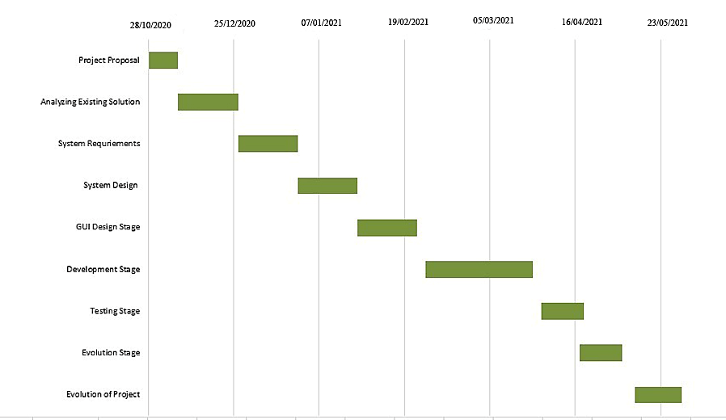The most influential constraint on our project is the amount of time available for development. To allow scheduling, estimation will have to be used to determine the probable length of time that each stage will require.

Figure 3.1 Gantt Chart.

chapter IV  
  
Methodology

A software development methodology is similar to a cooking recipe. A software development methodology, like a recipe, tells Us how to build a software. The ultimate goal of software methodology is to create high-quality, maintainable software in a reasonable time frame and at a reasonable cost. A successful software development methodology describes how all of our tools, techniques, and practices work together to create a winning Project.

4.1 Process Model

Software process have to include main functionilities of the software and the constrains (Specification) .Software needs to be designed and programmed . A software must meet the specifications and to cope up in the software competion we need to evaluate our software .

4.2 Different Software Process ModelS

1. Waterfall Model.
2. V-model
3. Iterative and Incremental Model
4. Spiral Model
5. Iterative Development Model
6. Agile Model
7. Big Bang Model
8. DevOps Model

4.3 Why we choose Spiral model (SDM) ?

The spiral model combines iterative project development from evolutionary implementation of a prototype model with the systematic and controlled features of the sequential waterfall model. The spiral model is better suited for large-scale projects that require consistent improvement and refinement with each iteration around the spiral.The output of one iteration's specific activities is a small proof-of-concept (POC) prototype, which is part of the larger software and is used to gather user feedback. The same activities are repeated in subsequent spirals, with refinement of the POC prototype, to produce a working model of the software called build with a version ID/number. Each version ohf the build is distributed to users in order to gather feedback for future enhancements in the next version until the final system is developed.

The difficulty in calculating the Gas price, the cost of running a smart contract on a public blockchain such as the Ethereum platform, is particularly high for large-scale projects with complex smart contract coding.

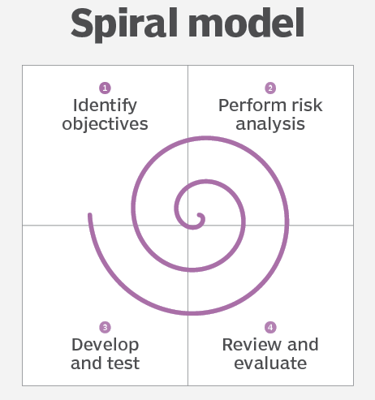

Figure4.2 Agile Model [9]

4.4 Agile model implementataions

As we used agile approach in our project. We completed the phases properly one after another to avoid confict in development. The phases are described below in detail:

****4.4.1 Requirements****

It is the primary period of the development where every one of the prerequisites accumulated and documented. For our project we have examined previous related systems and the users. After that we have finalized our system features.

4.4.2 Design

As we are finished the testing and requirement analysis of our project .Now it’s time for desiginig the frontend part . In that stage we use React js , the javascript framework , to develop a dynamic frontend part. To make our project eye cathing we used Material UI , Bootstrap, React js Styled Components to style different parts of page components .

4.4.3 Implementation

As we achiving the product requirements and design , It’s time for starting our implementaiton or development stage in web development terminology we can say we are now going to Backend system development.

In this phase we strictly follow the spiral model . It helps us to be on track of project requirement and takes us to next steps. We hard coded a function and then test it and optimize it and then we this funciton for our final figured function .

We impleement user backend using solidity and web3.js and admin backend using Laravel with phpMyAdmin .

****4.4.4 Testing****

As testing is very important for Sdlc model . We first test our wallet connection by Ethereum Tester and Ganache .In blockchain as everything is node , we node test to keep everything smooth. For Admin Backend we Test our Api .

We observe every error and failed response in our project . Then we debug it and also pay attention to corner stage for which the error are causinig.

We also checked our project using White Box testing and Truffle Migration testing in white box approach .We will presenting system testing in chapter 6 ‘System Implementation and Testing”.

4.4.5 Deployment

As we are now in the Deployment stage , we previously debug and log to console bar to detect any hiding error. And Then Now our project is ready for Deployment.Once it is Deployed to production ,Now It is ready for everyone to use in website .

4.4.6 Review & Maintenance

We regularly keep an eye on Maintenance so that we can provide our visitors with the best possible user experience.keeping Updated with valuable information, fixing broken links, removing duplicate pages to boost our website traffic.

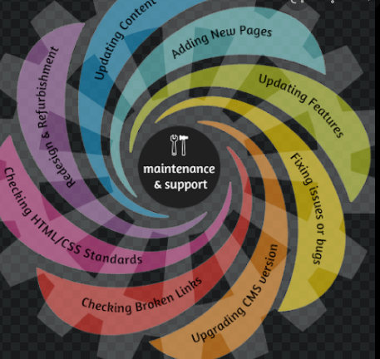

Figure4.2 Spiral Model for Software Development [10]

4.5 Limitations of Spiral model

There are some limitations of using Spiral model in porject [11] -

1. Difficulty in time management. As the number of phases is unknown at the start of the project, so time estimation is very difficult.
2. A large number of intermediate stages necessitate an abundance of documentation.
3. Spiral development is best suited for large projects and necessitates risk assessment expertise.

chapter V  
  
System ANalys7is

A system is a special design that is physical and functional need. System analysis is conducted for the purpose of studying a system or its parts in order to identify its objectives [13].

5.1 System Analysis

System analysis is the technique of studying a system or its components in order to identify its objectives. It improves the system and ensures that all the components of the system work efficiently to accomplish their purpose.

5.2 Data flow of Dapp-Linkedin App

Data flow is which is the way of sending data to server and receive them to android application. The process is figured out below:

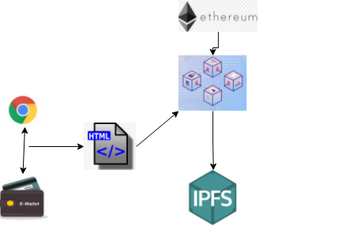

Figure 5.1: System Data Flow of Decentralized Social Network

Dispatcher

Callbacks

Actions

Web APi Utils

Web Api

Store

Actions Creators

React Views

Change Events + Store Queries

User Interactions

Figure 5.2: System Data Flow of Decentralized Social Network

5.3 Data view

In Our Dapps we show post of user using grid view. In a post there is two part one is text and other is image .As we request for user data , then the post of every user will be appeared in Grid view. In our Dapps we followed a excenent view of post so that grid view will be responsibe.

5.4 Security

In our Dapps we try to maintain best security practices. When ever a user try to post he/she must have to pay some gas fee and he must have to be connected with his metamask Etherum wallet. So if any user will not connect his metamask account he will not get the facility to post and even unable to see the post of others. We store the User Post data to IPFS(InterPlanetary File System) to secure the user Shared data .And IPFS will not give the main copy of the data rather it will give it a url hash value which is generated by IPFS system. To secure the user data to be shared by OSN system admin we used JSON Web Token (JWT) . Whenever a OSN admin pull all user data he/she must have to show a badge given the jwt authenticaiton system . If he shared the data and jwt token to others ,the surprising part of jwt token is that in every different login a different token will be given to admin .So there is no benifit of sharing every data to others, other’s will not get the data.

5.5 Version support

H As we building this website with the help of framework , we try to keep up to date of our every frameworks version up to date. Laravel 8, and solidity 0.5.0 version and web3.js version are supported by most of the web browser.

5.6 System Design

**Objective:** To change of the system detail into and operational system plan.

**Input:**  project goals, users requirements and specifications.

**Process:** Making alternatives to make economic benefits and building a qualityful system for major uses.

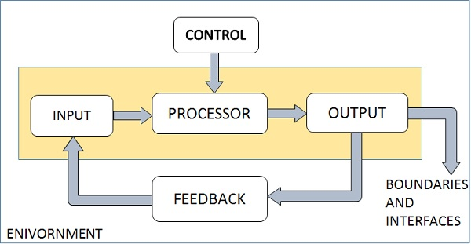**Output:** system design, schedule, software and hardware requirements.

Fig 5.1: Elements of system [13]

5.7 A general Model of software design process

DATA INPUTS

DATABASE DESIGN

DATA DESCRIPTION

REQUIREMENTS SPECIFICATION

PLATFORM INFORMATION

DATA ACTIVITES

A

INTERFACE DESIGN

COMPONENT DESIGN

ARCHITECTURAL DESIGN

DATA OUTPUTS

COMPONENT SPECIFICATION

INTERFACE SPECIFICATION

DATABASE SPECIFICATION

SYSTEM ARCHITECTURE

Figure 5.2: A general Model of software design process [14]

5.8   Flow chart Diagram

5.8.1 Flow Chart Diagram for Posts List

**Start**

**Deal Successfull , reading trading Information , Get hash**

**Log in to the Ipfs network via file hash and enter file hash**

Read Contract , the user participations in the transaction ?

**Transaction failure**

**Go to the Dapps**

**End**

Figure 5.3: Teacher Panel Activity diagram of the system.

5.8.2 Flow Chart Diagram for User Posting panel

**Start**

**Requestor signs across request transaction**

Is requestor’s key is connected with blockchain

**NNO**

**Drop transaction**

yes

Is requestor’s samrt contract is ok?

**Post Unsuccessfull**

**Post in ipfs**

**End**

Figure 5.4: Student Panel Activity diagram of the system.

5.8.3 Flow Chart Diagram for Admin Panel

**Start**

**User post list**

**Bearer token in APi?**

**Passport token**

**Passport**

**User list**

**post**

**End**

Figure 5.5: Admin Activity diagram of the system.

5.9   Use Case Diagram

5.9.1 Use Case Diagram for Teacher Panel

Registration Verification & Sign-in

Explore Assigned Courses

Give section, course notices and view official notices.



Give course assignment and preview submitted assignments.

View course request and different action of the courses.

**Teacher**

Create post, view all post and comment in academic forum.

Search and send real-time messages to students.

Navigate and edit profile

Sign-Out

Figure 5.6: Use Case diagram for Teacher Panel

5.9.2 Use Case Diagram for Student Panel

Registration Verification & Sign-in

Explore All Courses and register new course. View all registered courses.

Give section notice. View course notices and official notices.



View complete detailed list of department faculties.

Explore course assignments. Submit and preview submitted assignments.

**User**

Create post, view all post and comment in academic forum.

Search and send real-time messages to teachers.

Navigate and edit profile

Sign-Out

Figure 5.7: Use Case diagram for Student Panel

5.9.3 Use Case Diagram for Admin

Admin Login

View Dashboard

View and manage students list

View and manage teachers list

Manage courses and assign course to teacher



Manage assigned courses

View and manage student’s course registration information

**Admin**

Send messages to users.

Manage official notices.

Manage department forum.

Manage faculty information.

Manage department, semester, and session and section information

Sign-out

Figure 5.8: Use Case diagram for Admin Panel

5.10 Entity Relationship Diagram

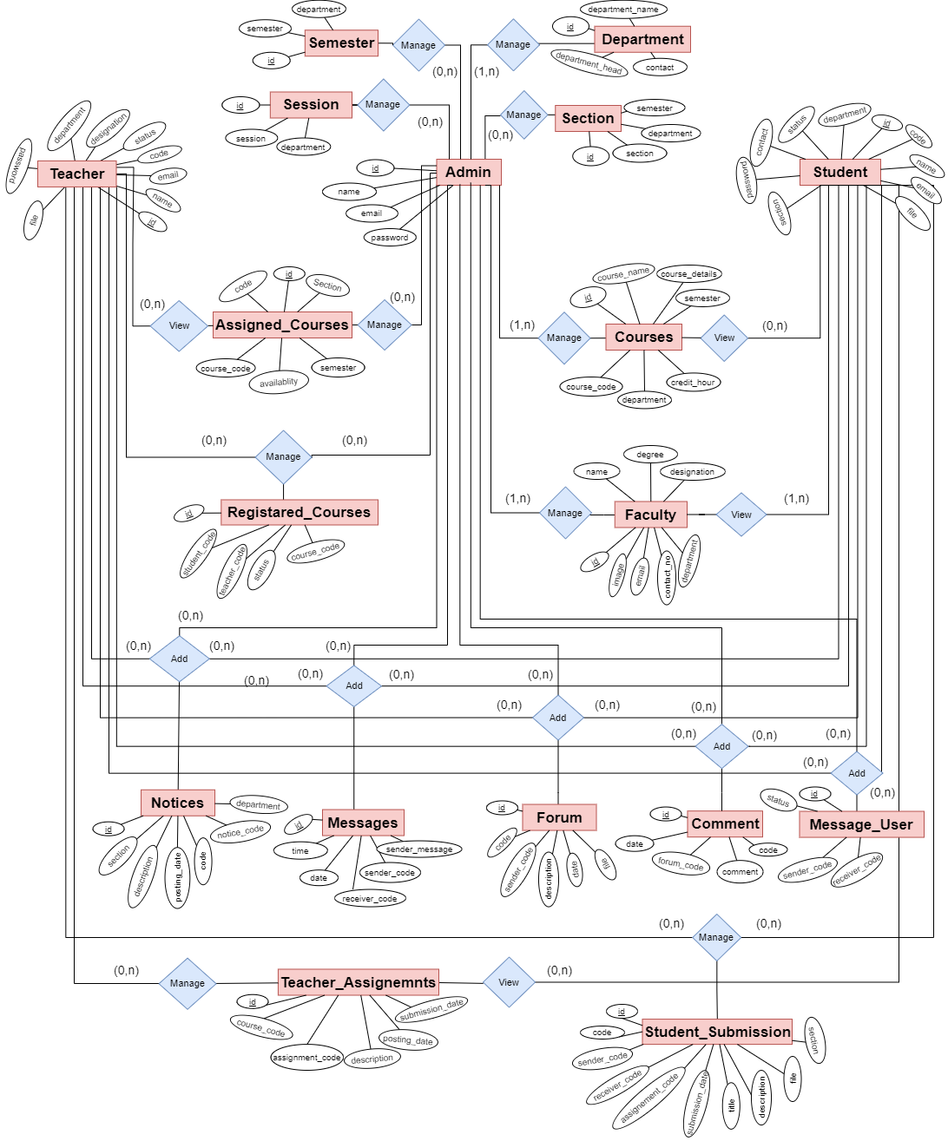

Figure 5.9: Entity Relationship Diagram

5.10.1 Logical Schema

* admin ( id, name , email, password)
* teacher (id, file, name, password, code, department, email, contact, designation status, token)
* student (id, file, name, password, code, department, email, contact, section, session, status, token)
* assigned_courses (id, code, course_code, course_semester, section, availability)
* courses (id, course_name, course_details, course_code, semester, credit_hours, department)
* registerd_courses (id, student_code, teacher_code, course_code, status, request)
* notices (id, notice_code, code, user_name, description, section, type, posting_date, departement )
* forum (id, forum_code, code, description, file, date, status)
* comment (id, forum_code, code, comment, date, status)
* message_user (id, sender_code, receiver_code, status)
* messages (id, sender_message, sender_code, receiver_code, date, time)
* teacher_assignments (id, assignenment_code, course_code, code, file, status, posting_date, submission_date)
* student_submission (id, assignment_code, teacher_code, course_code, titile, description, file, status, submission_date)
* faculty (id, name, image, degree1, degree2, degree3, desgination, department, contact_no, email)
* department (id, department_name, department_head, department_contact)
* semester (id, semester, department_name)
* section ( id, section_name, semester, departmnet_name)
* session (id, session, department_name)

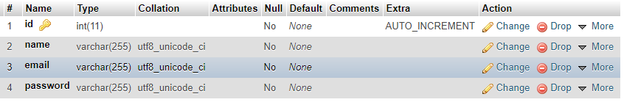

Fig 5.10 : Table ( admin )

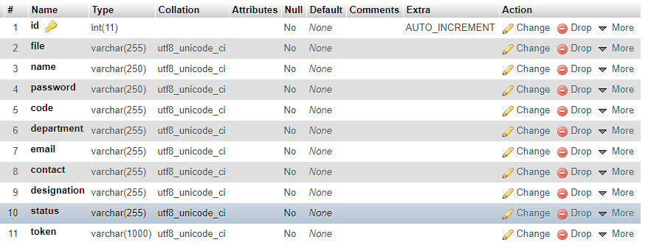

Fig 5.11 : Table ( teacher )

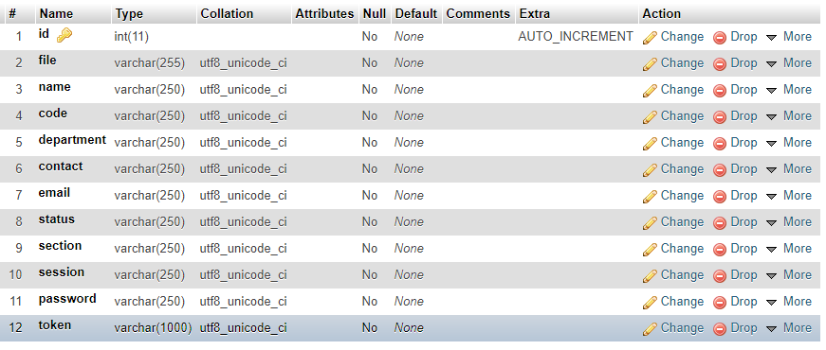

Fig 5.12 : Table ( student )

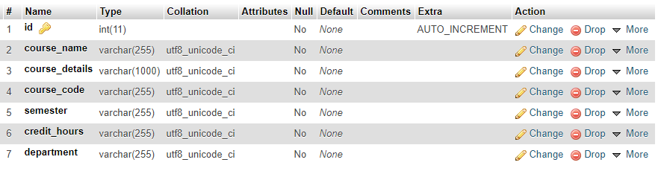

Fig 5.13 : Table ( courses )

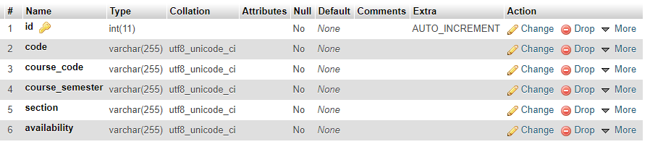

Fig 5.14: Table ( assigned_courses )

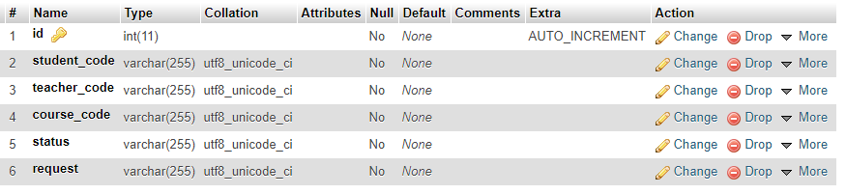

Fig 5.15 : Table ( registered_courses )

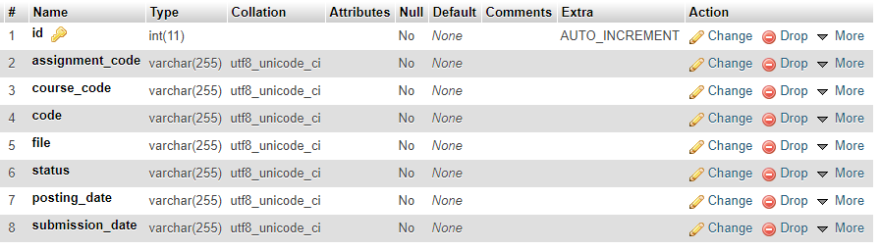

Fig 5.16 : Table ( teacaher_assignments )

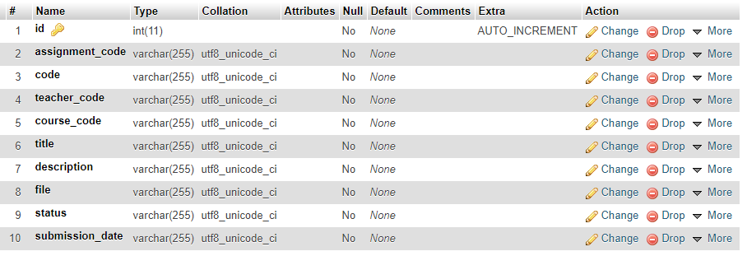

Fig 5.17 : Table ( student_submisions)

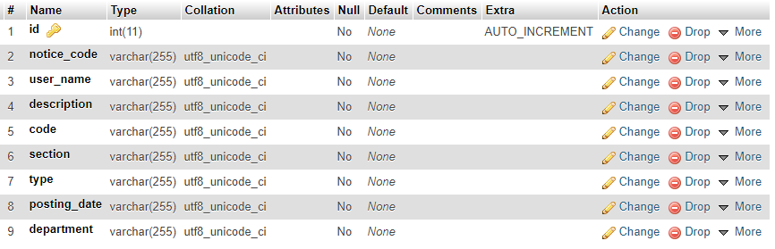

Fig 5.18 : Table ( notices )

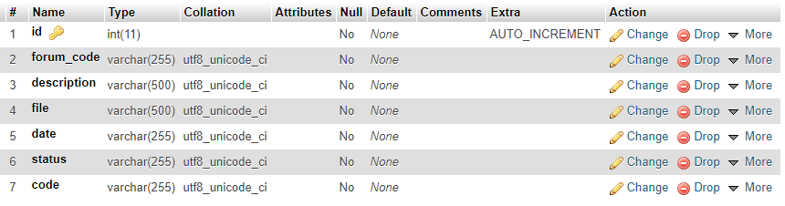

Fig 5.19 : Table ( forum )

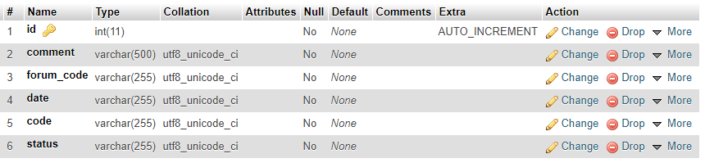

Fig 5.20: Table ( comment )

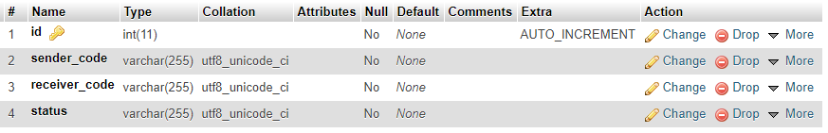

Fig 5.21 : Table ( message_user )

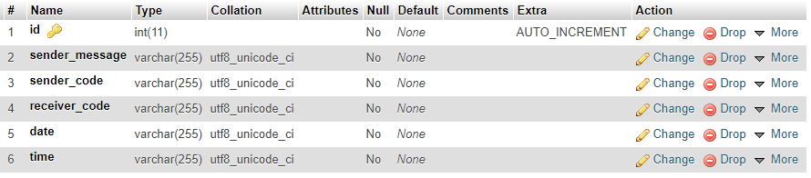

Fig 5.22 : Table ( messages )

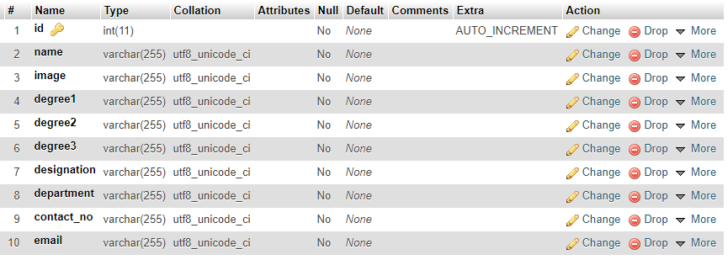

Fig 5.23 : Table ( faculty )

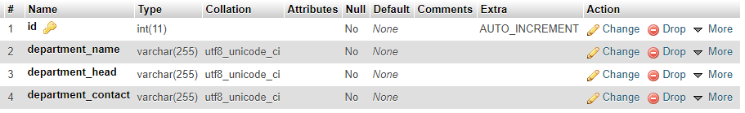

Fig 5.24 : Table ( department )

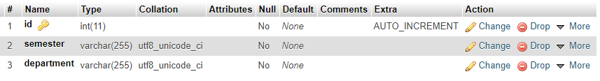

Fig 5.25 : Table ( semester )

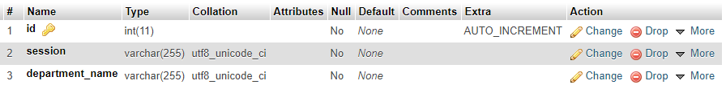

Fig 5.26 : Table ( session )

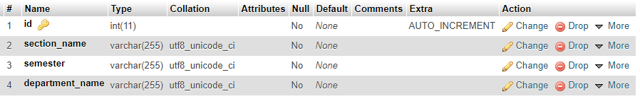

Fig 5.27 : Table ( section )

5.11 Data flow diagram

5.11.1 Level 0 DFD

Control

Administration System

Admin

Add/Edit Info/ Delete

View

Teacher

Content

Response

View

Student

Response

Content

Figure 5.28: Level 0 Data Flow Diagram for the Application

5.11.2 Level 1 DFD for Admin

Assigned Courses

**0**

**A Smart Course, Notice and Department Forum Management System**

Section notice, Official notice Add & Delete

**8.0**

Teacher

**2.0**

Teacher Info

Notice Info

Assigned Course List, Remove

**4.0**

Assigned Course

Info

Manage dept. forum, Add & delete post.

**7.0**

Forum Info

Student

Student Info

Students List Verify, Update, Delete

Courses

Course List, Add, Assign, Update & Delete

Teachers List Verify, Update, Delete

Course Info

**1.0**

**3.0**

Faculty List, Add, Update & Delete

Faculty Info

Manage messages to user & delete

**9.0**

Message Info

**6.0**

Course Registration List & Manage

Course Registration Info

Course Registration

Faculty

Forum

Notices

Message

**5.0**

Figure 5.29: Level 1 Data Flow Diagram for Admin of the Application.

5.11.3 Level 1 DFD for Teacher

**0**

**A Smart Course, Notice and Department Forum Management System**

Explore all assigned courses & manage courses.

**1.0**

Search & Send message to students.

**6.0**

Post section and course notices & view official notices

**2.0**

Post and comment in forum. Manage posts

**5.0**

Assigned Course Info

Notice Info

Forum Info

Message Info

**7.0**

Teacher

Teacher Info

Update profile information

Manage course assignments for all registered students.

Manage all registered students for course.

Assignment Info

Course Request Info

**3.0**

**4.0**

Assigned Courses

Notices

Teacher

Assignments

Course Request

Forum

Messages

Figure 5.30: Level 1 Data Flow Diagram for Teacher Application.

5.11.4 Level 1 DFD for Student

**0**

**A Smart Course, Notice and Department Forum Management System**

Explore all courses & manage courses.

**1.0**

Search & Send message to teachers.

**6.0**

Post section notice & view course, official notices

**2.0**

Post and comment in forum. Manage posts.

**5.0**

Course Info

Notice Info

Forum Info

Message Info

**7.0**

Update profile information.

Student Info

Submit & Manage course assignments for all registered courses.

View and Contact department faculties.

Assignment Info

Faculty Info

**3.0**

**4.0**

Courses

Notices

Student Submission

Faculty

Forum

Messages

Student

Figure 5.31: Level 1 Data Flow Diagram for Student Application.

chapter VI  
  
System Implementation & Testing

Android applications are spreading widely and are rapidly used as an operating system for Smartphone, tablet and other devices. Android development is now focusing on giving support to people in every other steps of life. By using our user friendly android application the students and the teachers will get an easier way to be connected with own department.

6.1 SYStem implementetaion in details

In android app there are 2 panels.

* User Panel
* OSN Owner Panel

6.1.1 User Panel

To use the teacher panel user must need to complete signup process of teacher. After department admin verification user can sign-in to the home activity and access the functionalities. In our application branch Teacher Panel has versatile features

* **Forum**
* All Posts – Teacher can see all forum posts and can give new post to the forum. Can add comments to any post.
* My Posts – The previous given post will be shown here. Can delete or modify any post.
* **Messages** – Teacher can search by student Id, name or section. Send new messages to students and can see message list.
* **Profile Setting** – Can update all information, image etc.
  + 1. OSN Owner Panel

To use the teacher panel user must need to complete signup process of teacher. After department admin verification user can sign-in to the home activity and access the functionalities. In our application branch Student Panel has versatile features

* **Courses**
* All Courses – Student will see all courses of the department.
* My Courses – All registered courses will appear here.
* **Notices**
* Section Notice – Student can give notice to his section and see the list of previous section notices
* Course Notice – Student can see the notices of the course that they have registered.
* Official Notice – Student can see official notices which has given by the department.
* **Assignments**
* Course Assignments – Student will see the list of assignments which are given for their registered courses. Can separate the assignment by course.
* My Submissions – Can preview the submitted assignments. Delete submission.
* **Faculties** – Complete detailed list of department faculties with tap to contact feature.
* **Forum**
* All Posts – Student can see all forum posts and can give new post to the forum. Can add comments to any post.
* My Posts – The previous given post will be shown here. Can delete or modify any post.
* **Messages** – Student can search by teacher name. Send new messages to teacher and can see message list.
* **Profile Setting** - Can update all information, image etc.
  + 1. Admin Web Panel

This panel provides the unique facility to the Admin to control all the aspects of the whole system. This web panel offers a user-friendly and interactive experience to the Web admin. Adding new objects and updating them. Viewing and managing all old data. Actions of the web panel is very easier to understand and also easier to maintain all updated information. In our application Admin Web Panel is much versatile. It consists of 14 sub panel activity.

* **Dashboard** – Home window after log in. Admin can access important features from here.
* **Teachers** – All teachers list. Admin will verify newly registered teachers. Admin have update and delete operation.
* **Students** - All students list. Admin will verify newly registered students. Admin have update and delete operation.
* **Courses** - All course list will be shown here. Admin can create, update, assign or delete courses.
* Assign Course – Admin can assign course to teacher.
* **Course Registration** – All students information’s of course registration will be appear here. Admin have delete operation.
* **Assigned Courses** – List of all assigned courses will be shown here. Admin have delete operation.
* **Faculty Information** – Admin can manage information of faculty list. Which will be shown in student panel as ‘Faculties’ section.
* **Forum** – Admin can manage all post of department forum also can create new post to the forum.
* **Notice** – All notices given by the admin will appear here as list.
* Section Notice – Admin can add notice for any section of the department.
* Official Notice – Admin can give official notice of the department.
* **Message** – Admin can send personal message to any Student and Teacher.
* **Section** – Admin can manage sections. Admin have create, update or delete operation for section.
* **Session** – Admin can manage sessions. Admin have create, update or delete operation for session.
* **Semester** – Admin can manage semester. Admin have create, update or delete operation semester.

6.2 UI Design Implementation

Here we will describe the UI Implementation into three main parts. These are:

1. Student Panel
2. Teacher Panel
3. Admin Panel

6.2.1 Student Panel

Student panel is one of the major part of the SDMS application. Because we implement this system by giving the supreme priority to the students and teachers.

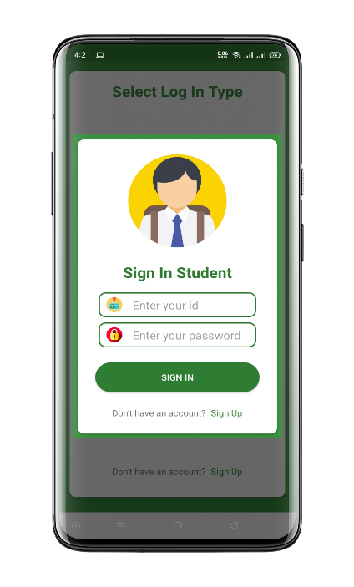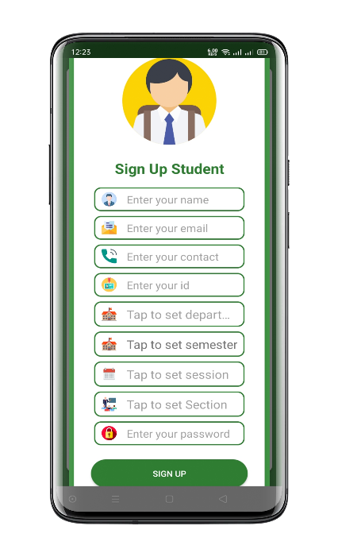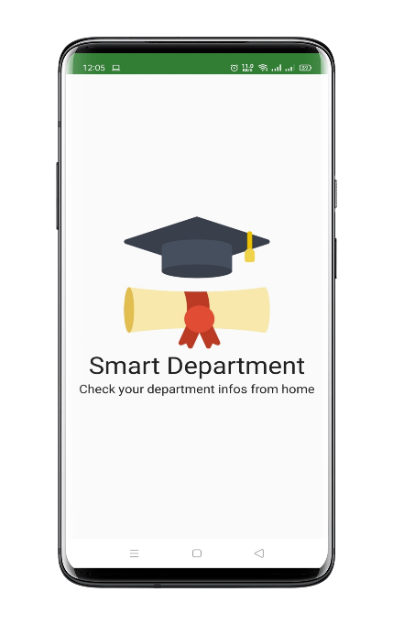Student can register himself by tapping on Sign-Up button. For Signing Up, student have to provide correct Full Name, Email, Contact number, Student ID, Department, Semester, Session, Section & Password. For Sign In, student have to provide correct Student ID & Password.

Fig 6.1:Student Sign Up Activity and Sign In Activity

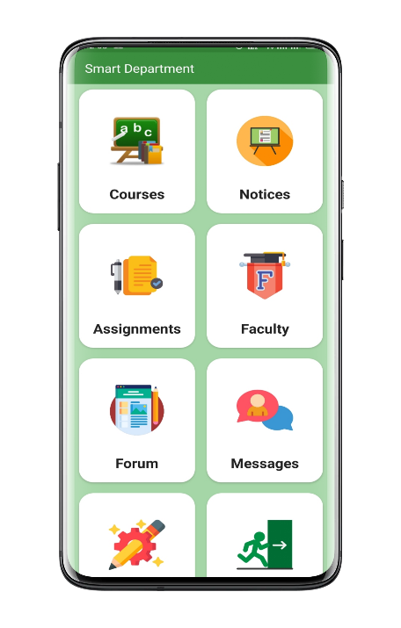After successful sign-in home activity will appear. Here students will see all short cut menu of the application.

Fig 6.3:Home Activity

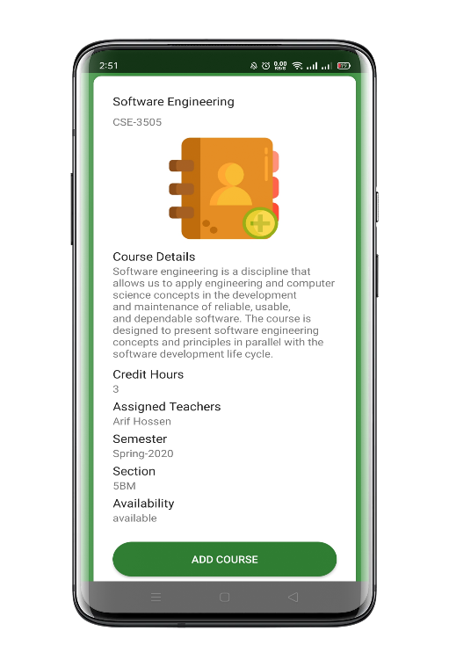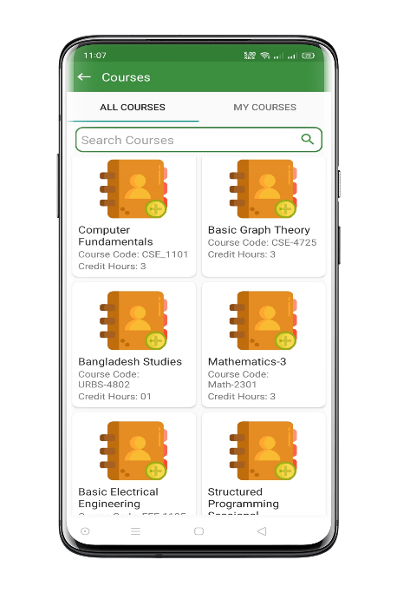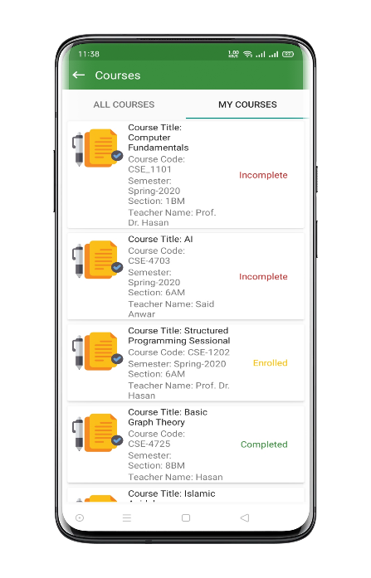**Courses:** Here student will see all courses which are offered and in “My Courses” activity the courses registered by them will appear.

Fig 6.4: Student Courses Activity

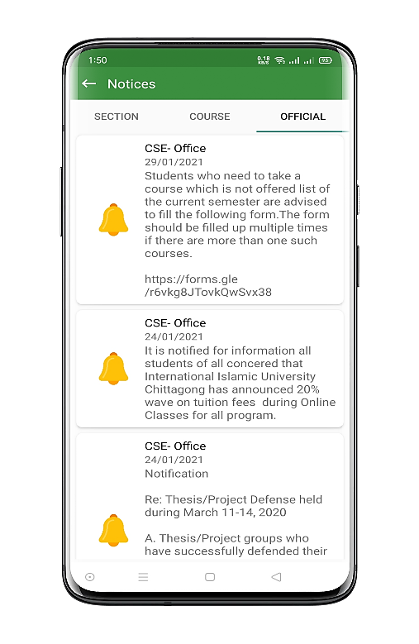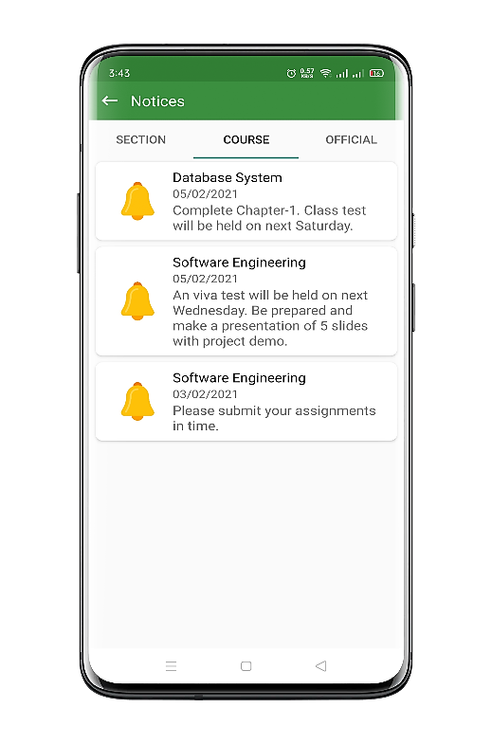**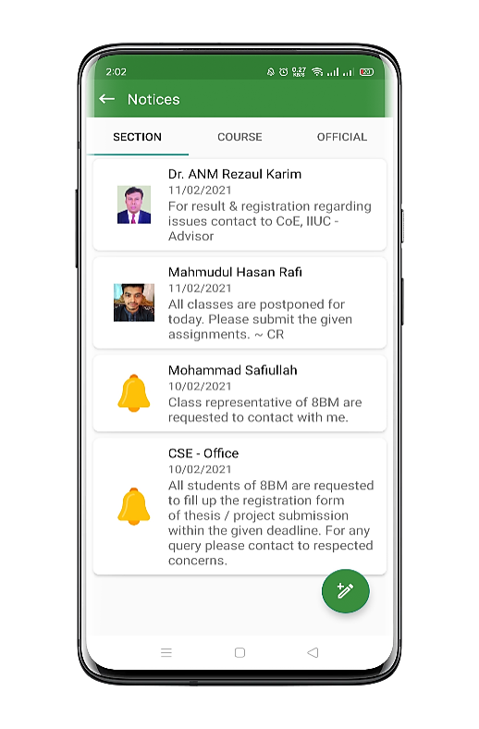Notices:** Students will get here the official notices announced by department, course notices announced by course teacher and section notices given by class represntative, teacher and department office.

Fig 6.5: Student notice activity

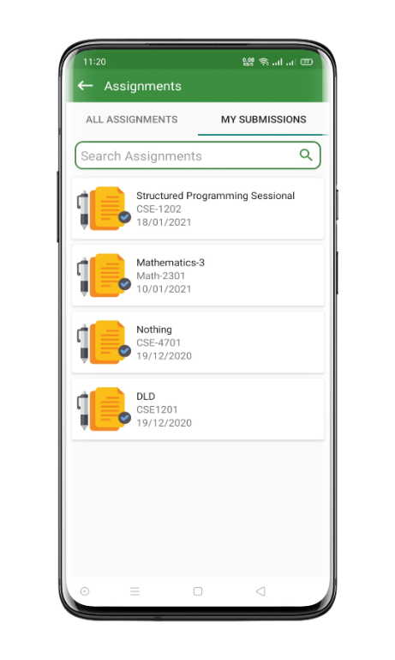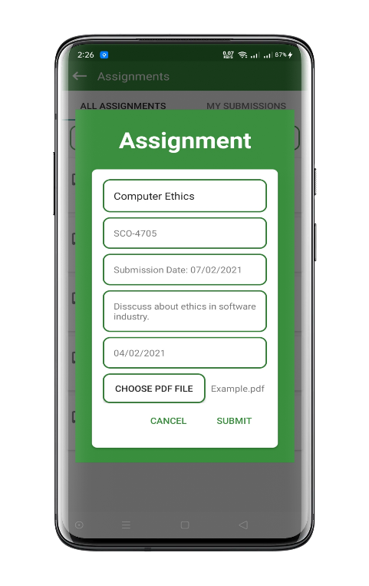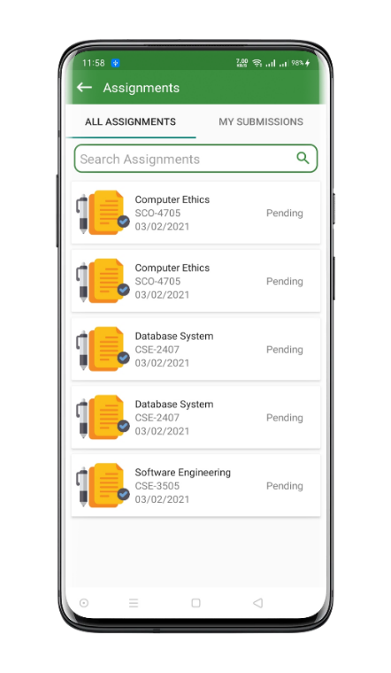**Assignements:** Students will see the assignments given by the course teachers and also can preview their submitted assignments.

Fig 6.6 : Student assignments activity

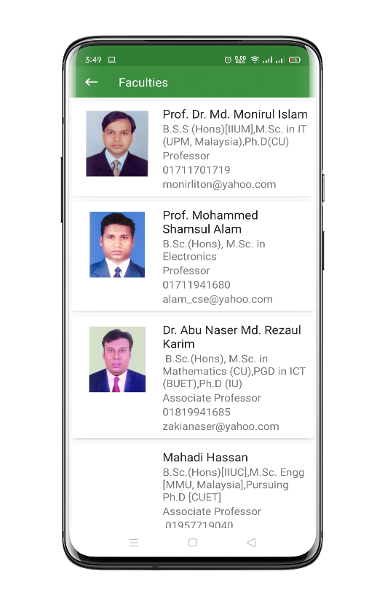**Faculties:** Students can explore all the faculty information in detailes from this activity and can contact easily with tap to contact action.

Fig 6.7: Faculty Activity for Students

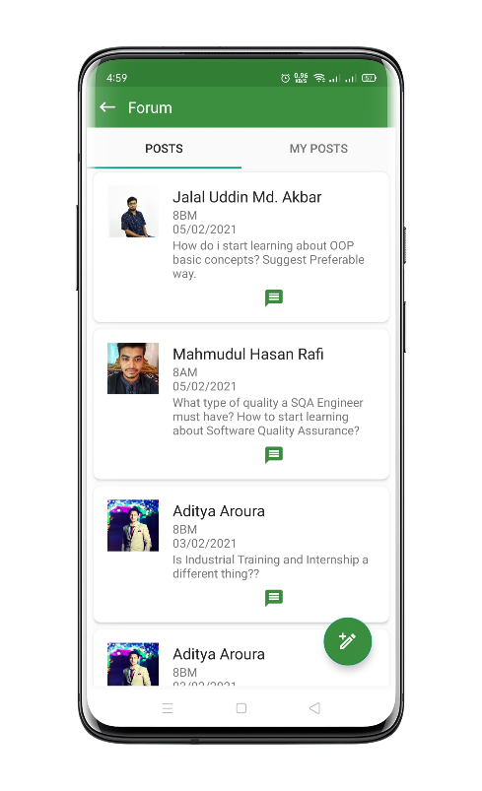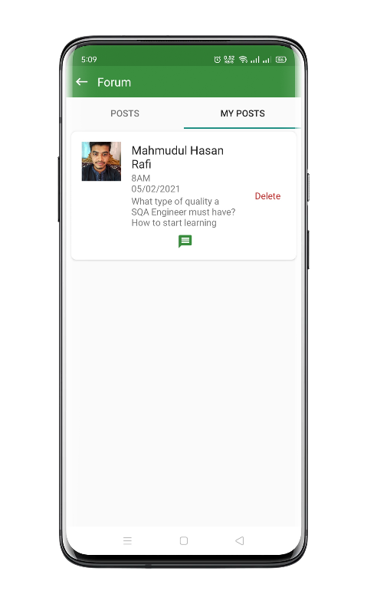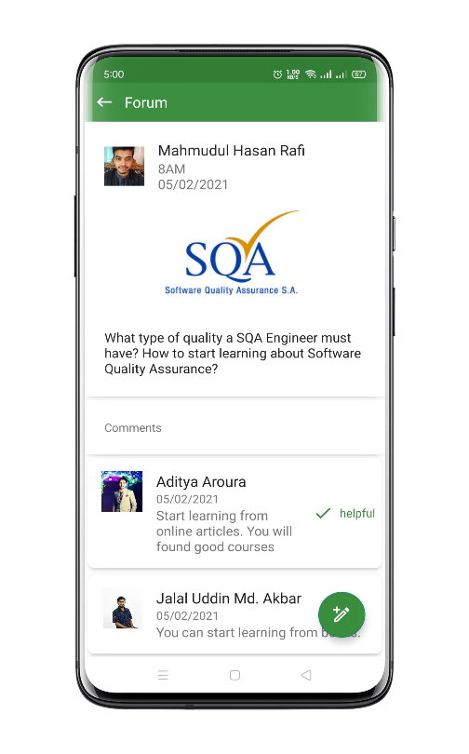**Forum:** Students can ask questions in forum and comment in others queries. In “My Post” activity student can manage their own posts.

Fig 6.8: Forum activity

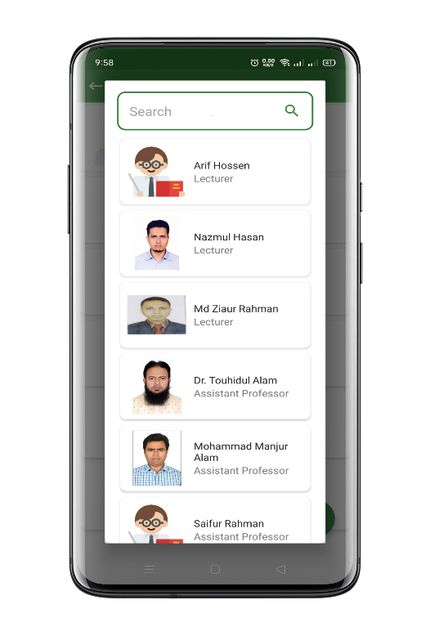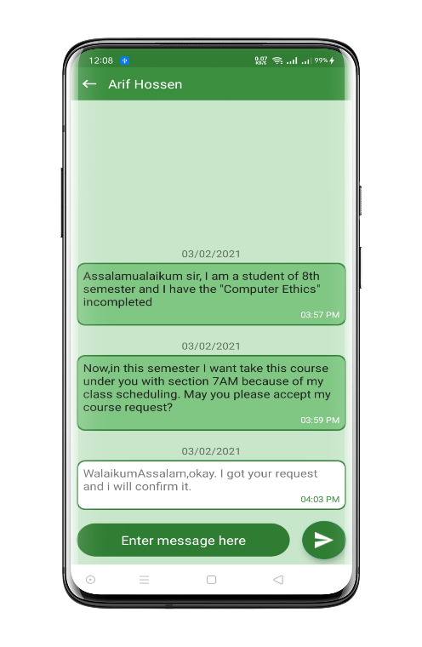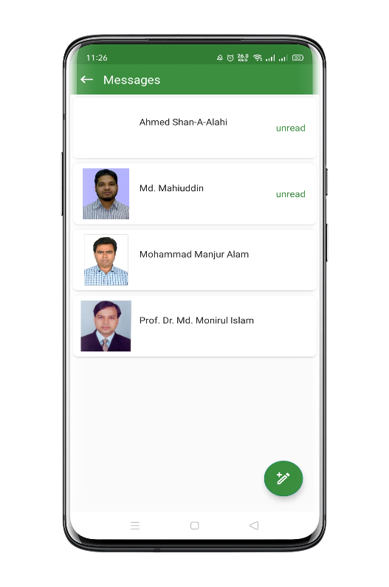**Messages:** Student can search for teachers by name and send real-time messages form this activity.

Fig 6.9: Student Message activity

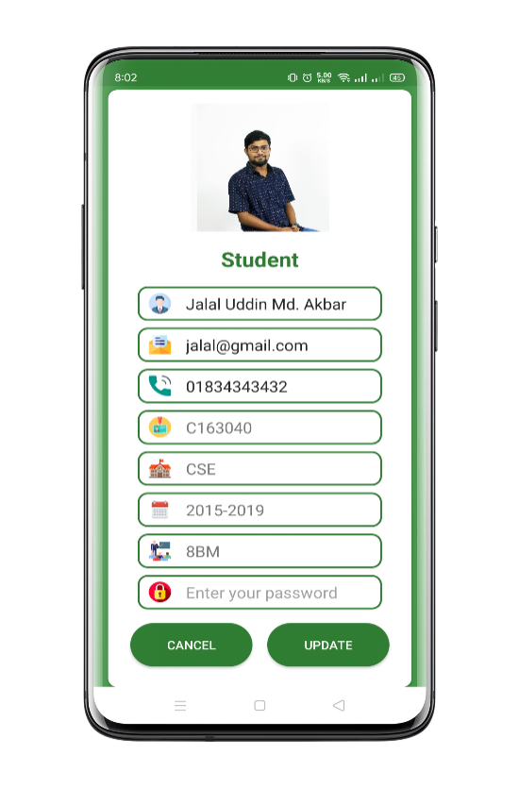**Profile:** On profile activity students can update their information and images.

Fig 6.10: Student profile update activity

6.2.2 Teacher Panel

Teacher Panel is another major part of SDMS APP. In this panel we did lot of improvement. App interfaces are user friendlies it is one of the main priorities of the application.

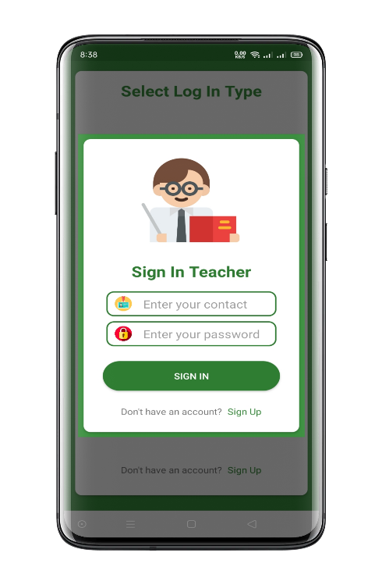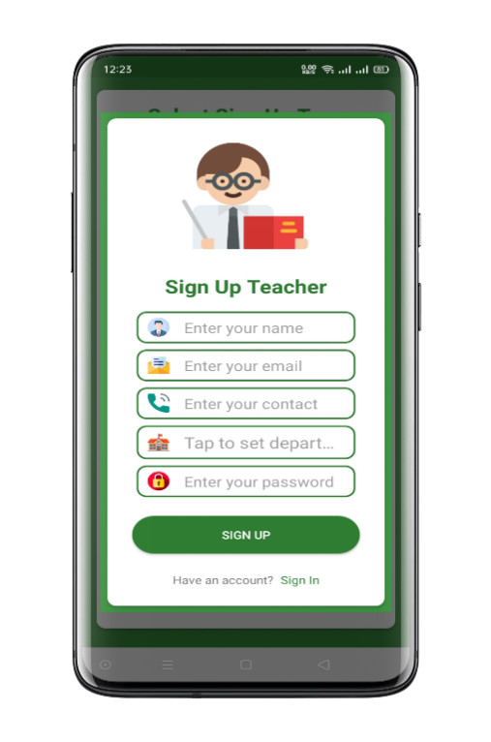Sign-up activity for teachers basically requires general information of the teachers to sign-up. General information like Name, Contact no, Email, Department and Password.

Fig 6.11: Teacher Sign-up activity

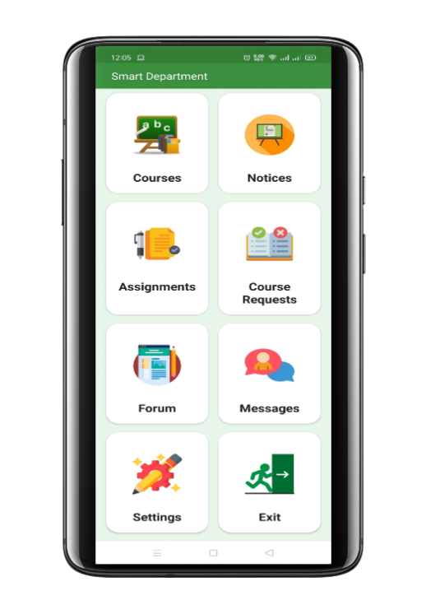After successful sign-in home activity will appear. Here teacher will see all short cut menu of application.

Fig 6.12: Home screen activity

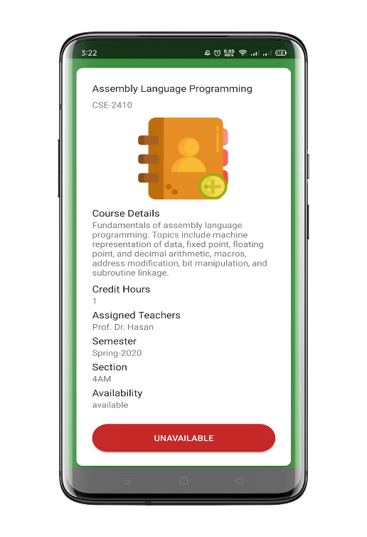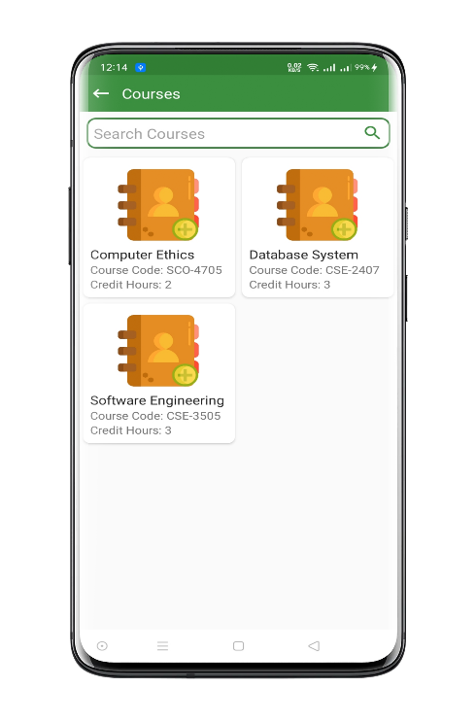**Courses:** In this activity courses which are assigned for the teacher from department will appear.

Fig 6.13: Teacher Courses activity

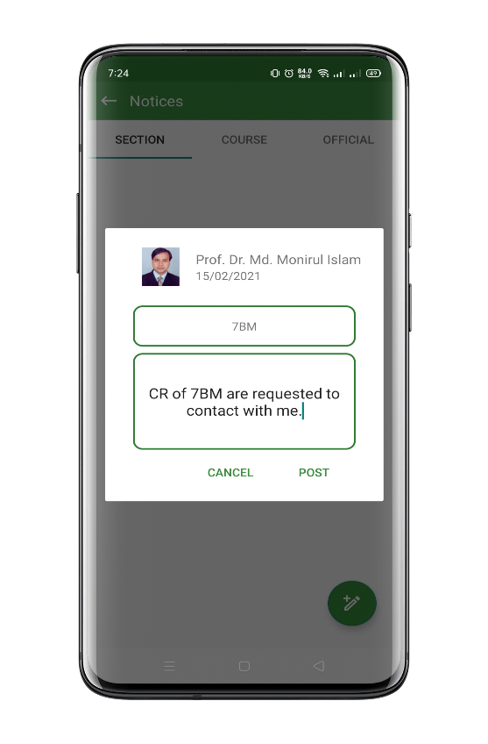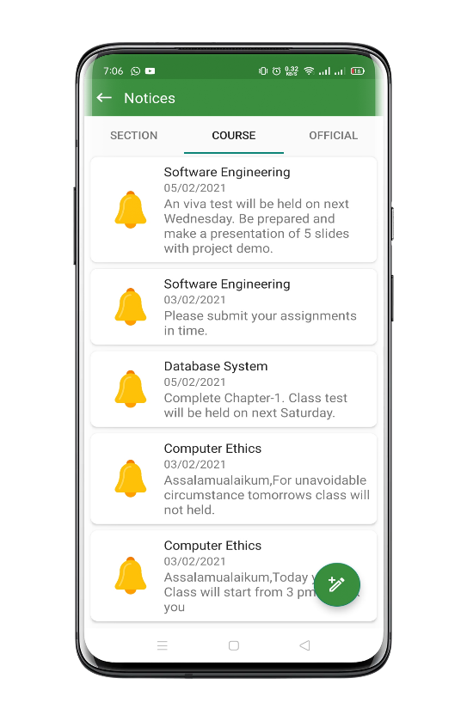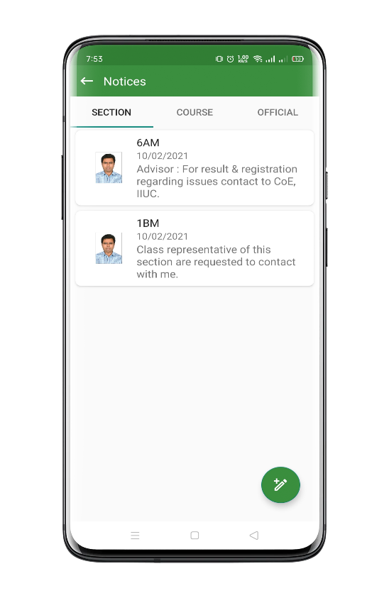**Notice:** In the notice activity, teachers can give notice to the assigned courses. Teacher can give notice to specific section. In the official notice tab official notices form department will appear.

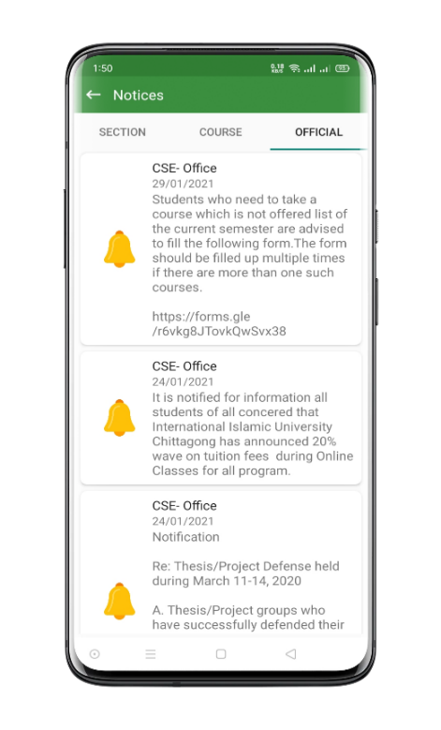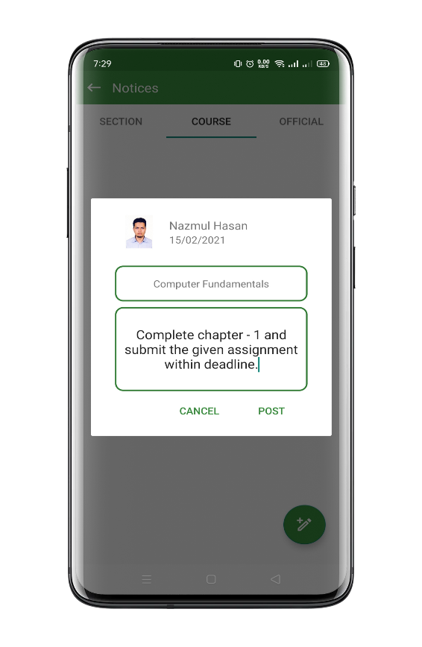

Fig 6.14: Teacher section, course and official notice activity

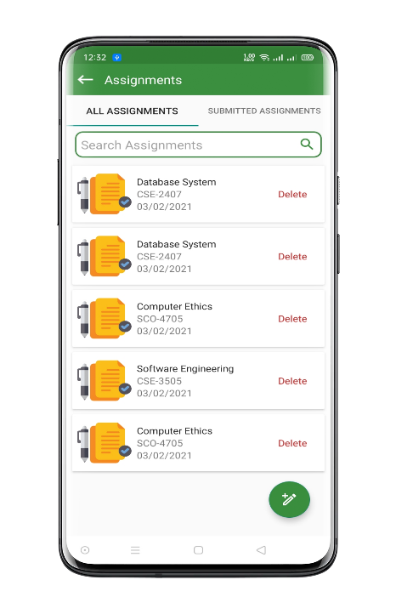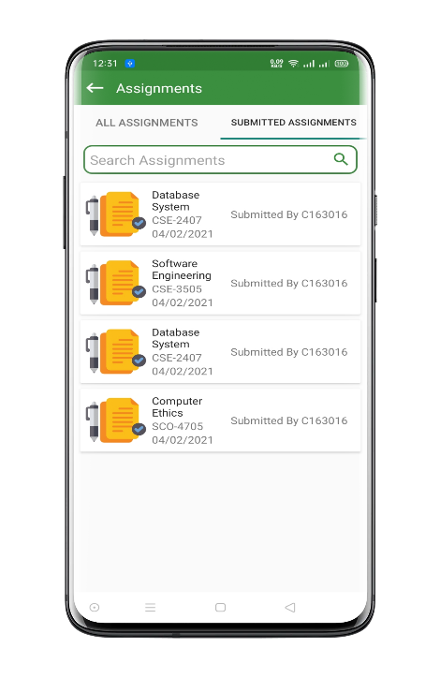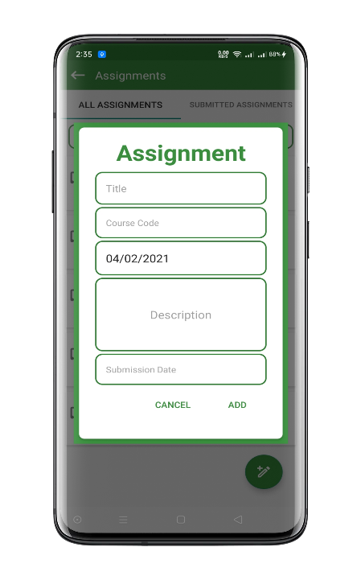**Assignment:** In this activity, all assignments added by teacher will appear and in the “Submitted Assignments” student submission will appear and teacher can preview the submission.

Fig 6.15: Teacher Assignment activity

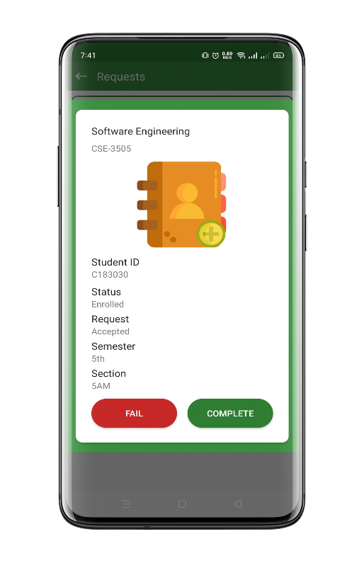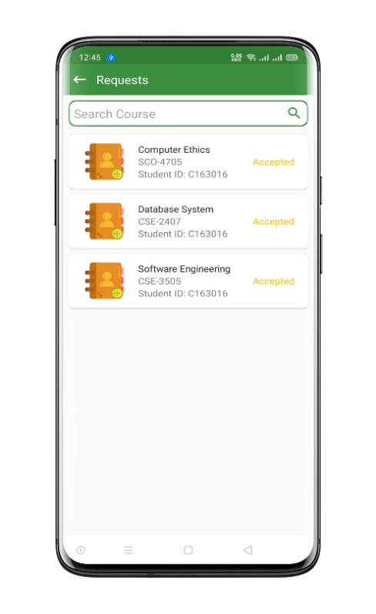**Course Request:** In this activity the course joining request by the students will appear and teacher can manage various course actions of students.

Fig 6.16: Teacher Course requests activity

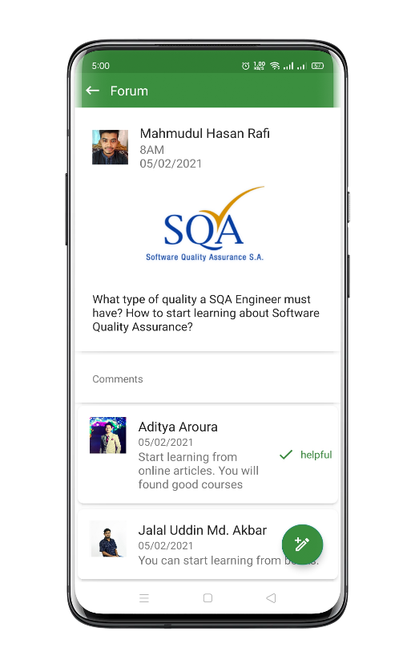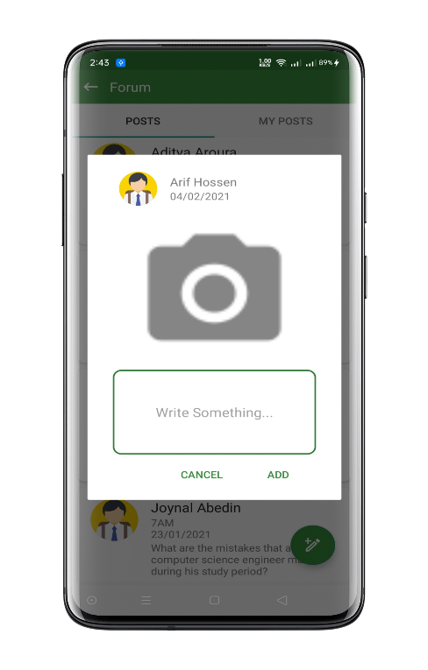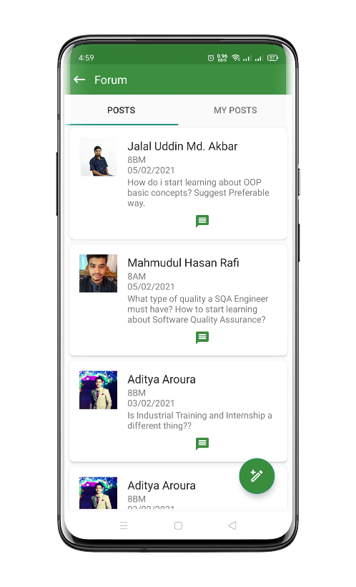**Forum:** In fourm activity teacher can post questions in forum and comment in others queries. In “My Post” activity teacher can manage own posts.

Fig 6.17: Forum activity

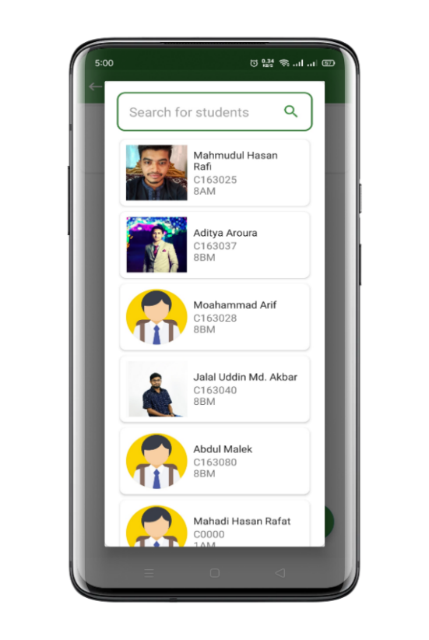**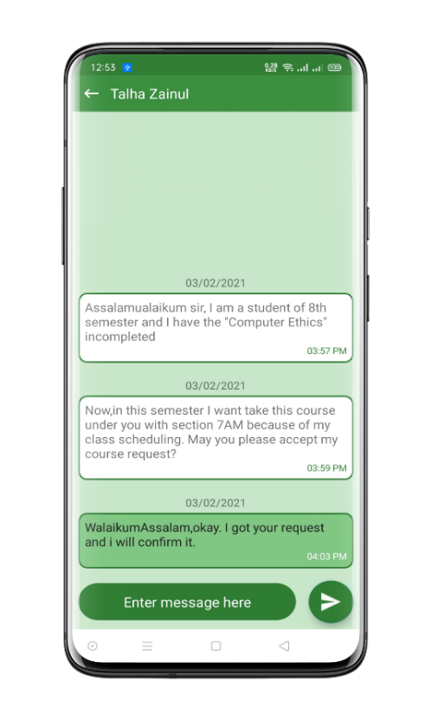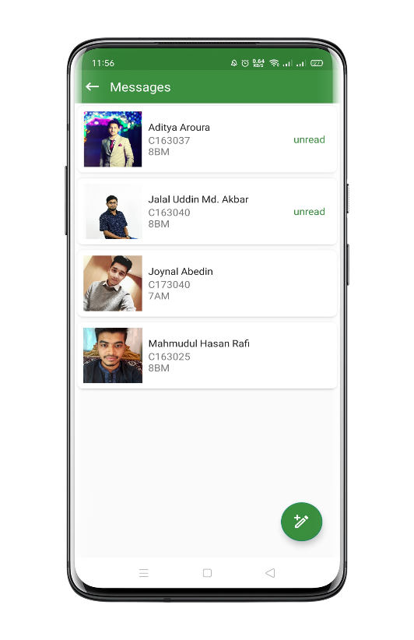Messages:** Teacher can search for students by name, id or section and can send real-time messages from this activity.

\\\

Fig 6.18: Teacher Message activity

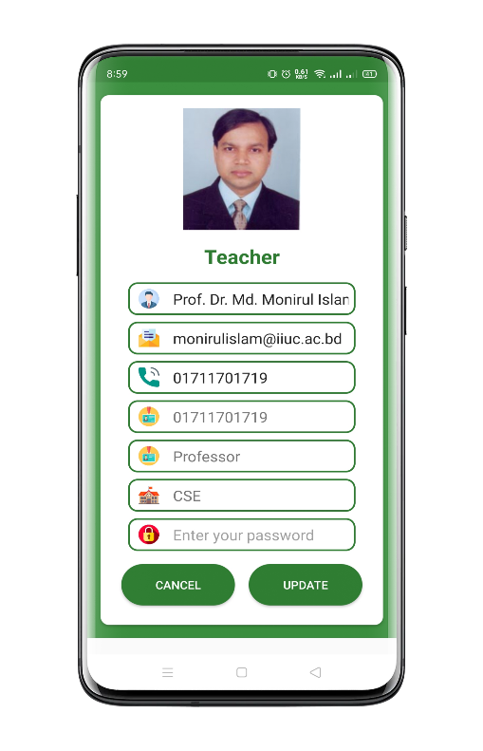**Profile:** In this activity teacher can update profile information and image.

Fig 6.19: Teacher profile update activity

6.2.3 Admin Panel

Admin Panel is managerial panel of our application. The management operation of different features are completed by admin.

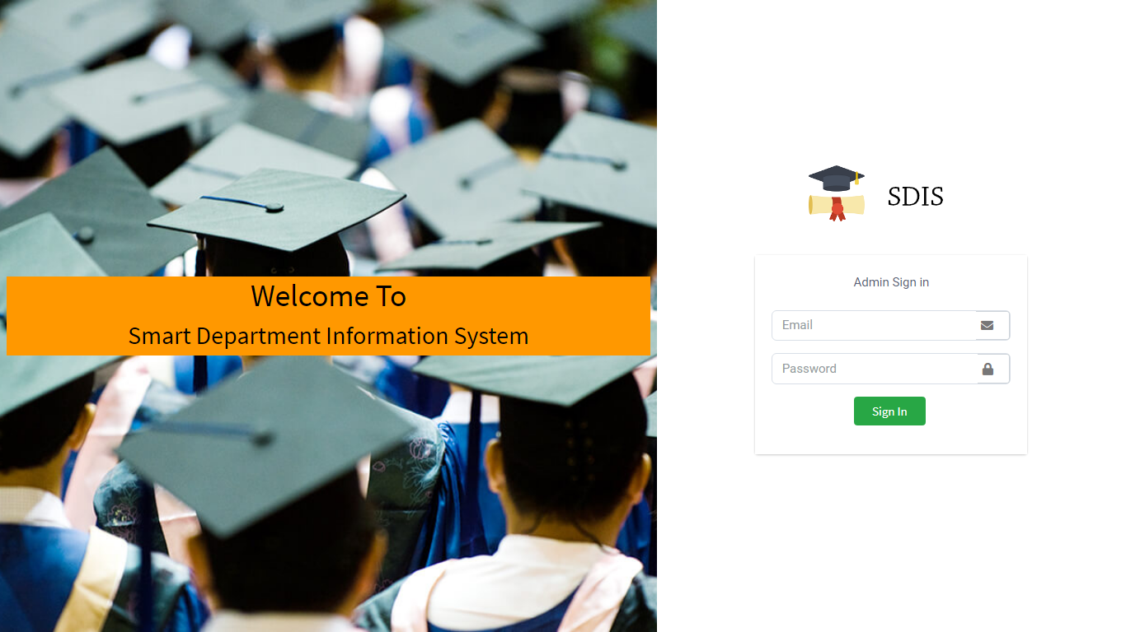

Fig 6.20: Admin panel sign-in activity

From here admin have sign-in to our application using their email & password.

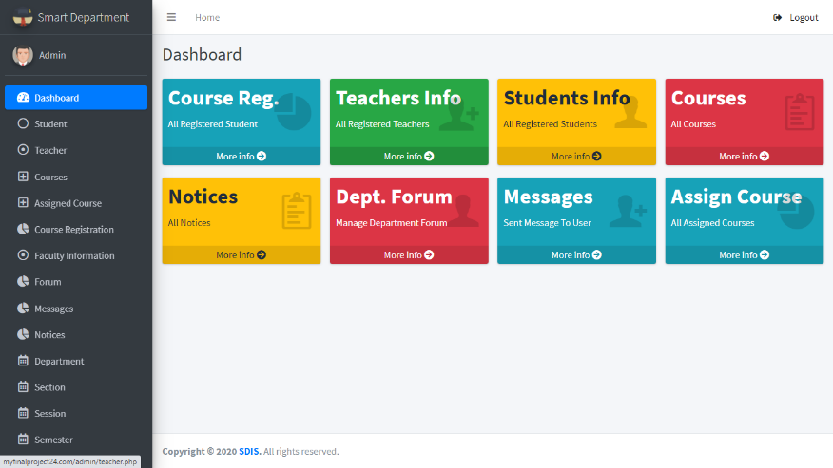

Fig 6.21: Dashboard for Admin

From dashboard admin can access all features of admin panel.

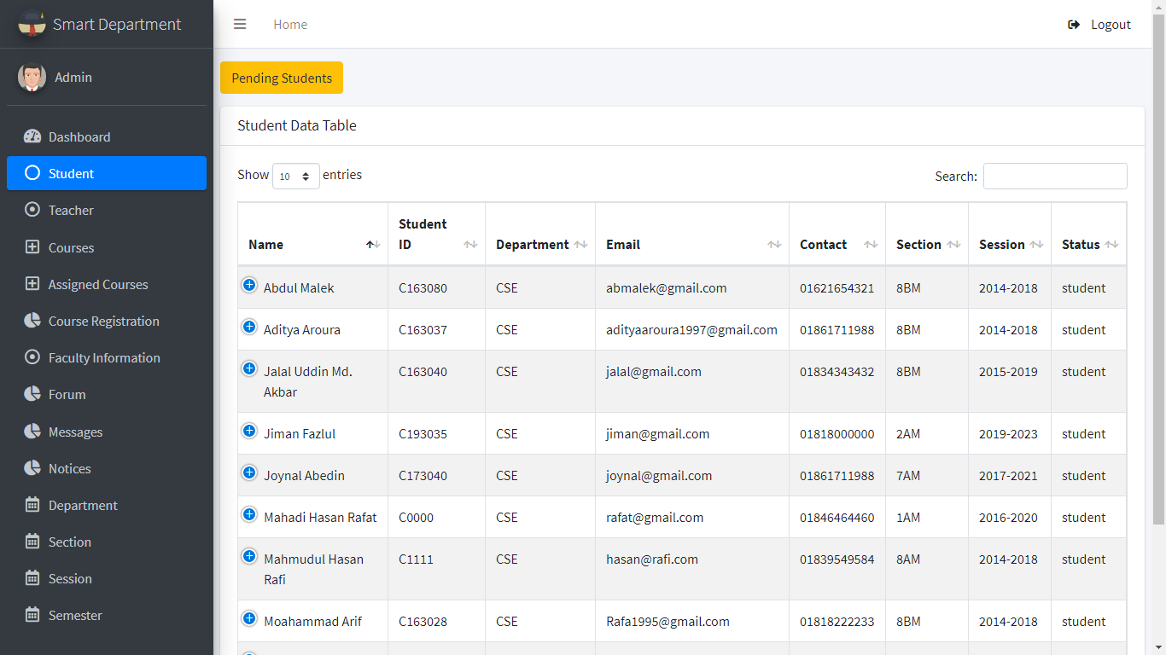

Fig 6.22: Student Management Activity for Admin

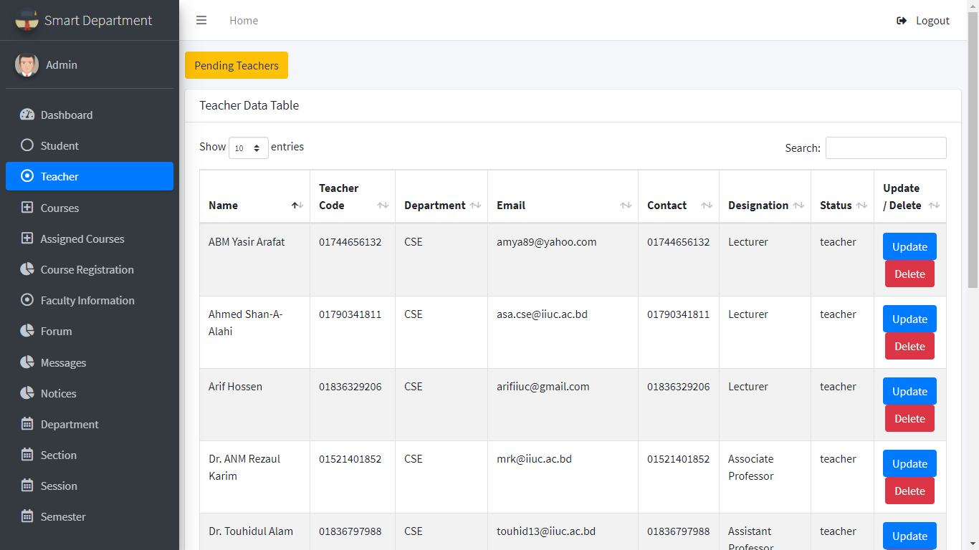Here admin can see the student’s information and can verify pending students. Admin can update and delete students Information.

Fig 6.22: Teacher Management Activity for Admin

Here admin can see the information’s of teachers. Admin can verify teachers and can update or delete teacher’s information.

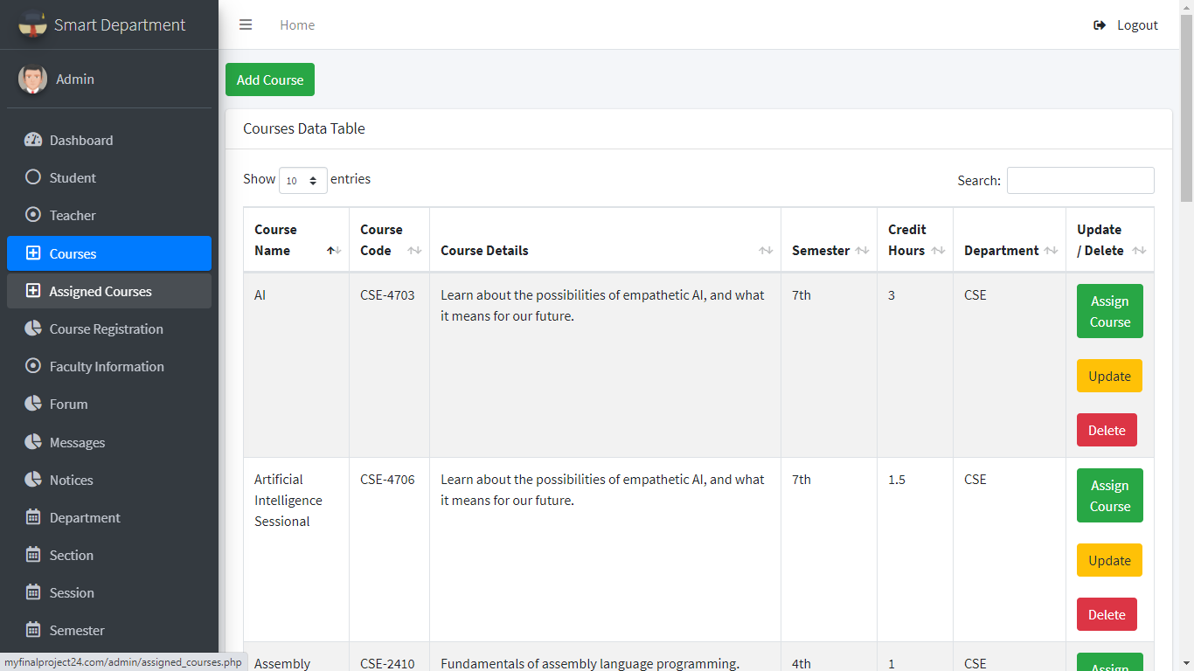

Fig 6.23: Course Management for Admin

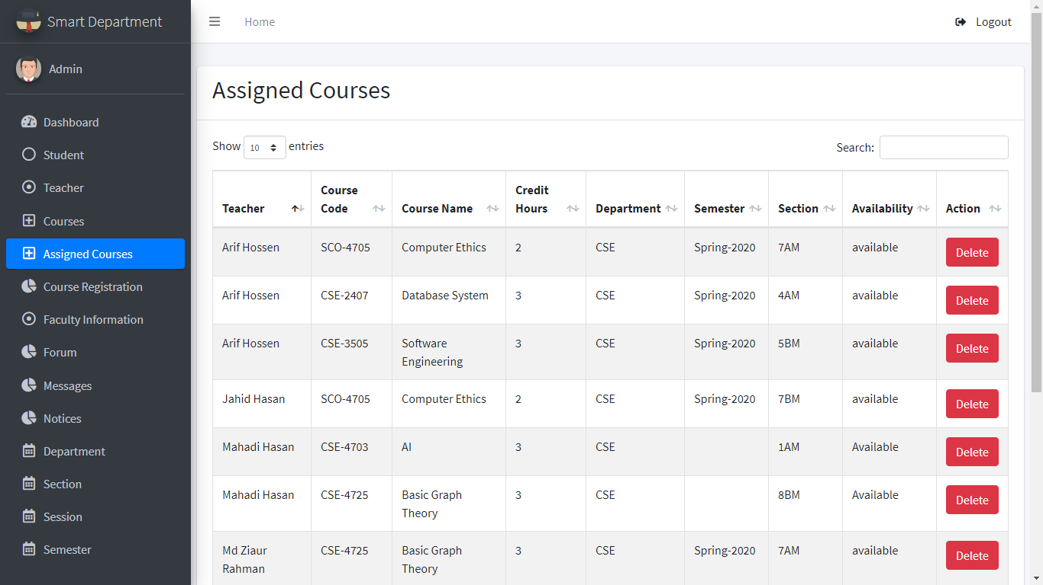In this course activity admin can add course. Here admin also can assign course to the teacher and can update and delete courses.

# 

# 

# 

Fig 6.24: Assigned Course Management for Admin

Here admin can see the assigned courses to the teachers. Admin also can delete the courses according to semester.

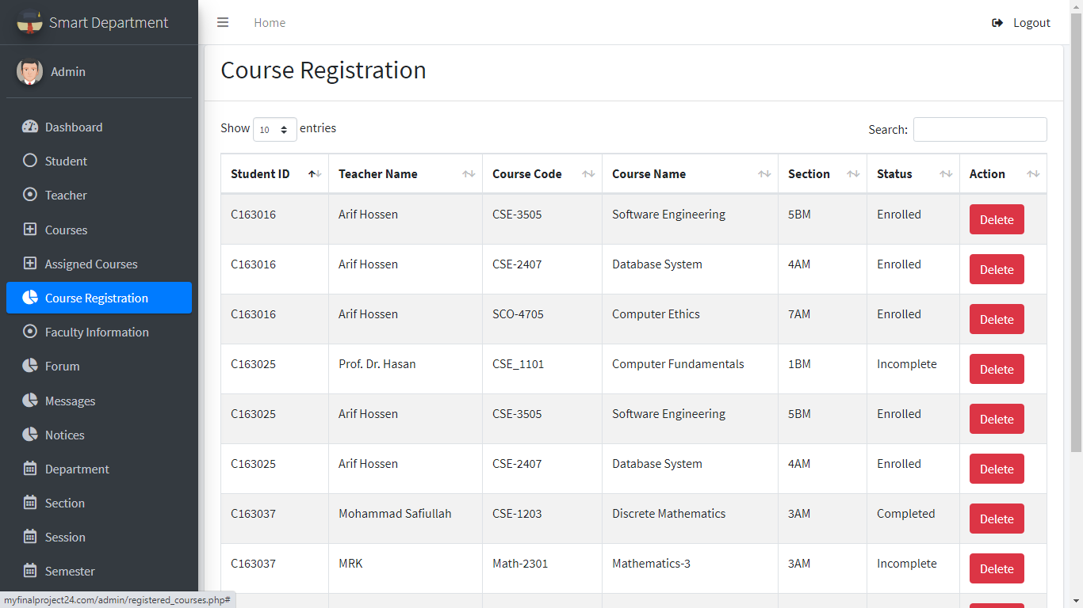

# 

Fig 6.25: Course Registration Management Activity for Admin

Here admin can see the registered courses by the students. Which student have taken which course under which teacher will be shown here. Admin also can see the status of the registered course.

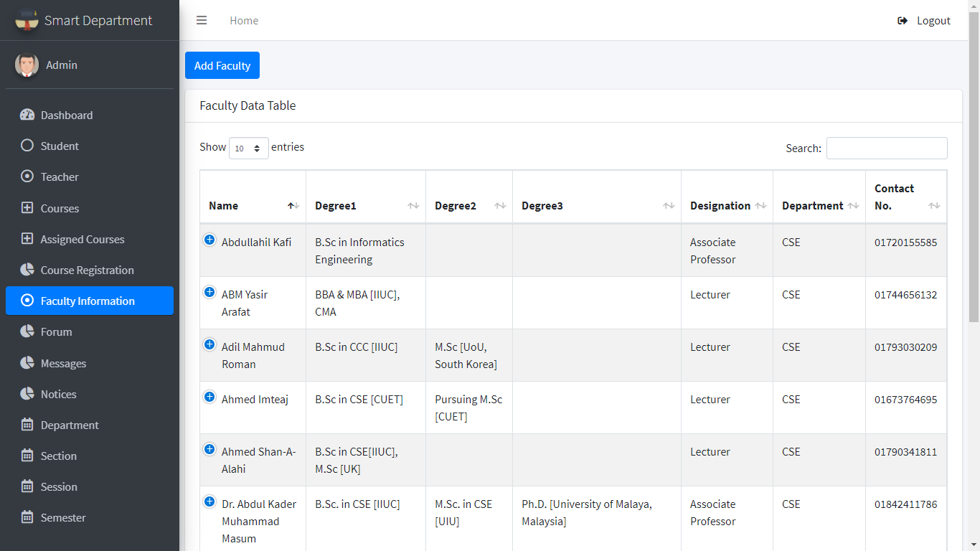

# 

Fig 6.26: Faculty Information Activity for Admin

Faculty Information activity shows the information of the faculty. Admin can manage faculty information of the department.

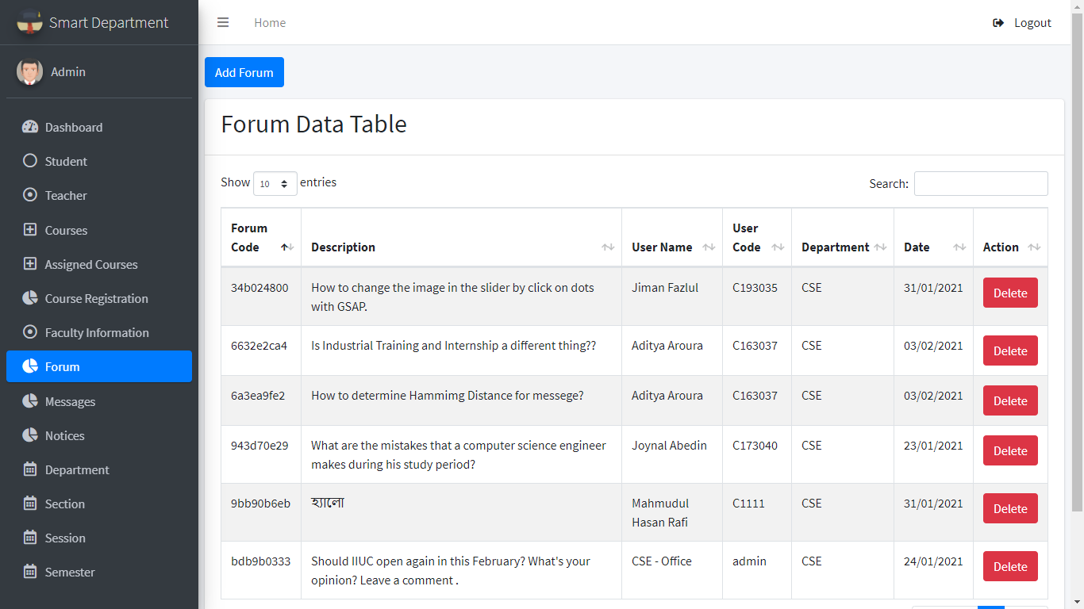

# 

Fig 6.27: Forum Management Activity for admin

In Forum activity admin can see the form posts and moderate the forum operation.

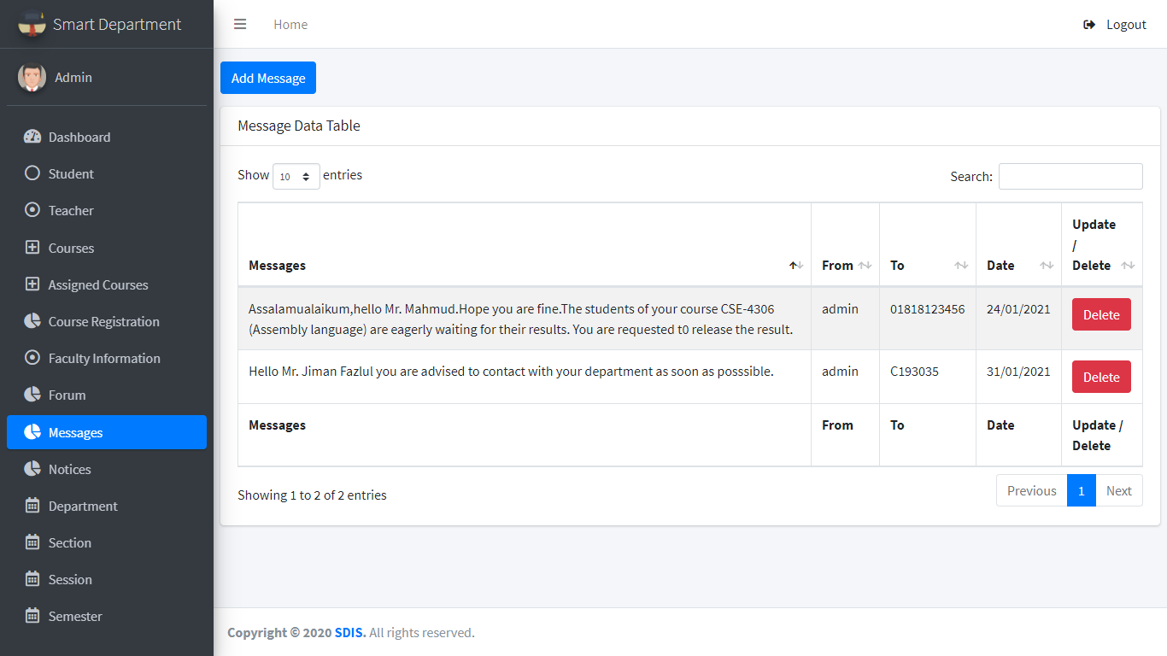

Fig 6.28: Admin Message Management Activity

Here admin can see the messages conversed with admin. Admin can send message to students and teacher both.

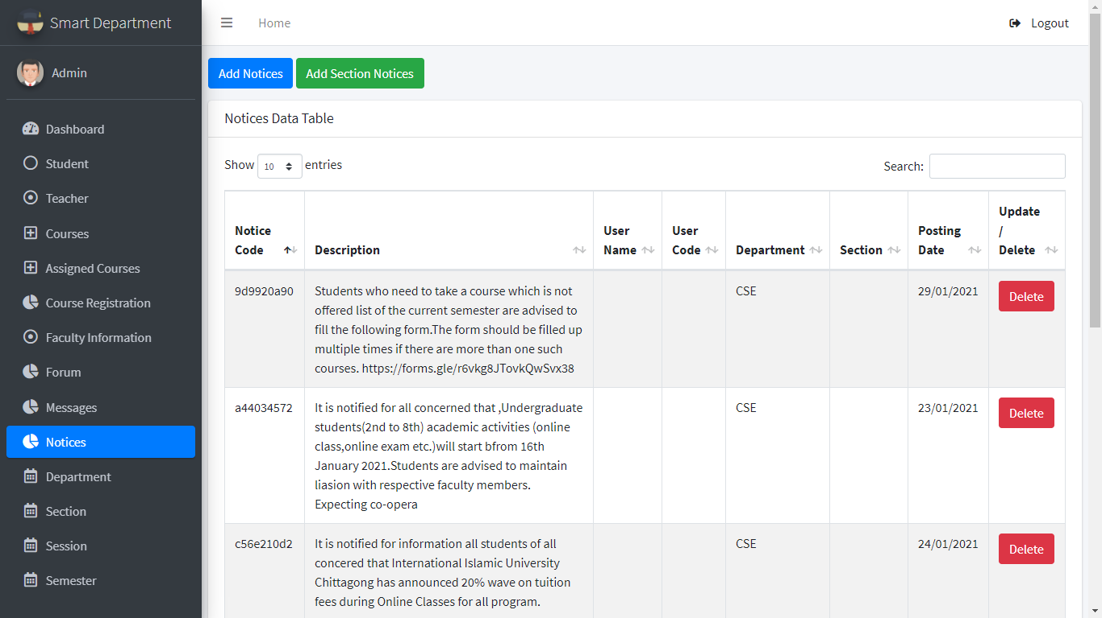

Fig 6.29: Admin Notice Management Activity

In notice activity admin can add official notices. Admin also can give sectional notices.

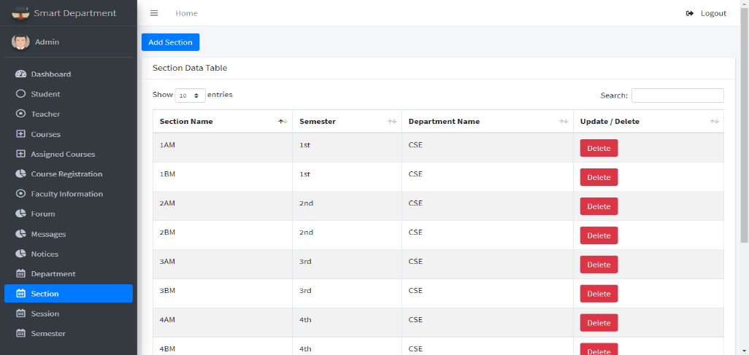

# 

Fig 6.31: Section Management Activity for Admin

In section management activity admin can add or delete section.

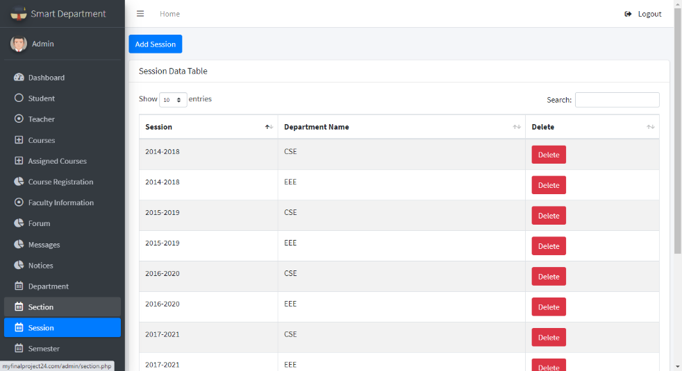

Fig 6.32: Session Management Activity for Admin

Form session activity admin can manage sessions of the department.

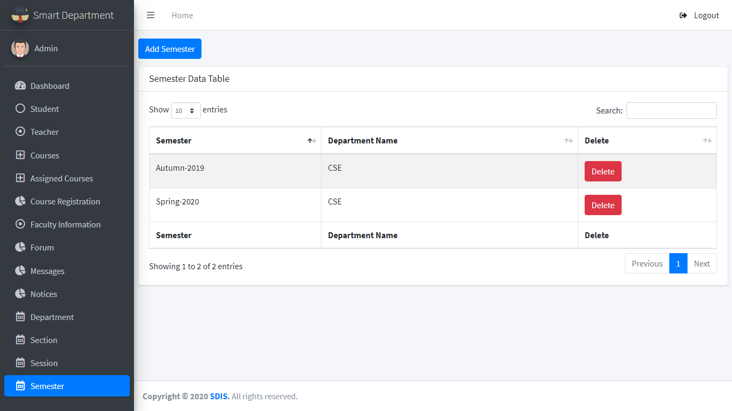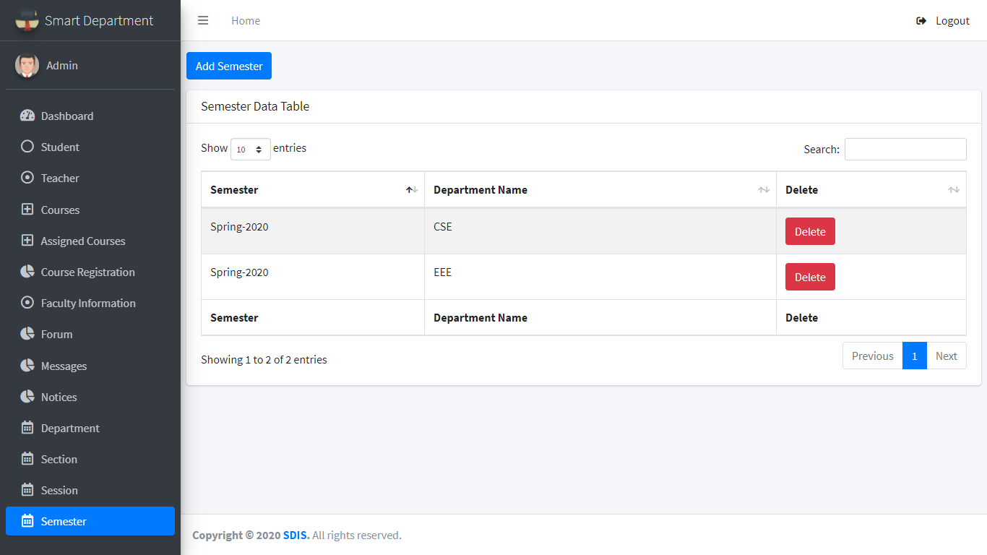

Fig 6.33: Semester Management Activity for Admin

In this semester activity admin can manage semester of the department.

6.3 TESTING

Testing is the process of verifying and validating the system. The objectives of testing are to ensure that the system programs is error free, guarantee the system end users can interact with the system well and ensure that the components of the system interface are working well.

6.3.1 Objectives of Testing

There have some different goals and objectives in software testing. The main objectives are as follows [16] -

1. Meets the requirements that guided its design and development.
2. Works as expected.
3. Can be implemented with the same characteristics.
4. To prevent defects.

6.3.2Testing Details

For our project we did two types of testing. As functional testing we did White Box Testing and as non-functional testing we did Usability Testing.

6.3.2.1 Functional Testing

* **White Box Testing**

In general, White Box Testing is performed early in the stage out. In this type testing all the lines, loops and logical expression and connections are tested by debugging the program [17] .We checked validation on every inputs of the project and debugged the system many times. There are few details:

* We have debugged all inputs which are mandatory as user inputs. We have tested another important field, file input. If file upload manager accepts all file type without specific one, then it can cause security issue to our database and server. We got error exception in debugger while checked with invalid or unknown file types.

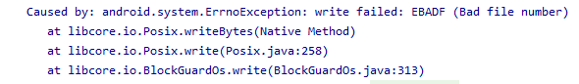

Fig 6.34: File type checking output

* 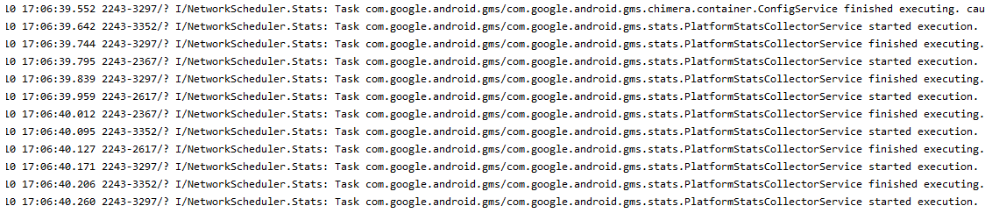App server connection request execution are tested with debugger network scheduler. We have completed this check without getting any error. At testing time it has started and finished execution with mentioned schedule request. No delay or error execution seen while testing.

Fig 6.35: connection request execution testing output

* 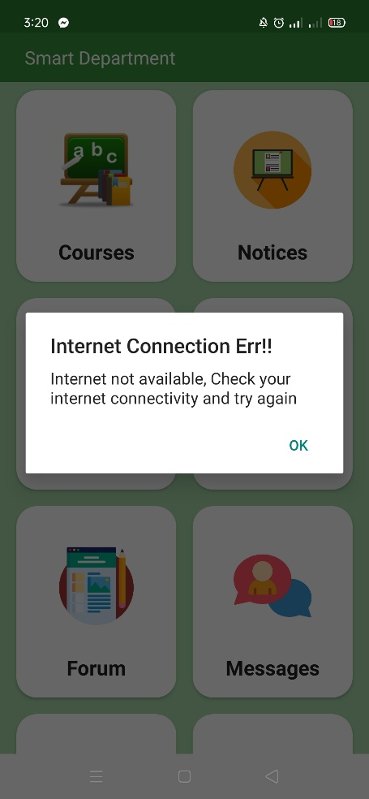App connectivity tested manually. In this test we have checked application connection manually. As we have used connection detector we see this application can detect no internet connectivity or connectivity with very lower bandwidth. It automatically stops running the application with validation to avoid operation failure.

Fig 6.36: Output of manual connection check of application

**6.3.2.2 Non-functional Testing**

* **Usability Testing**

Usability Testing is a non-functional testing approach. It means selecting some target user and let them use the application for a duration and get the feedback from the users. As our application is totally a new system with new concept. We did a usability testing to our system before launching it. We tested among 12 real users and the duration was 3 days of regular use. We got feedback from the users who have participated our usability test. In case of usability testing some question arises. Such as

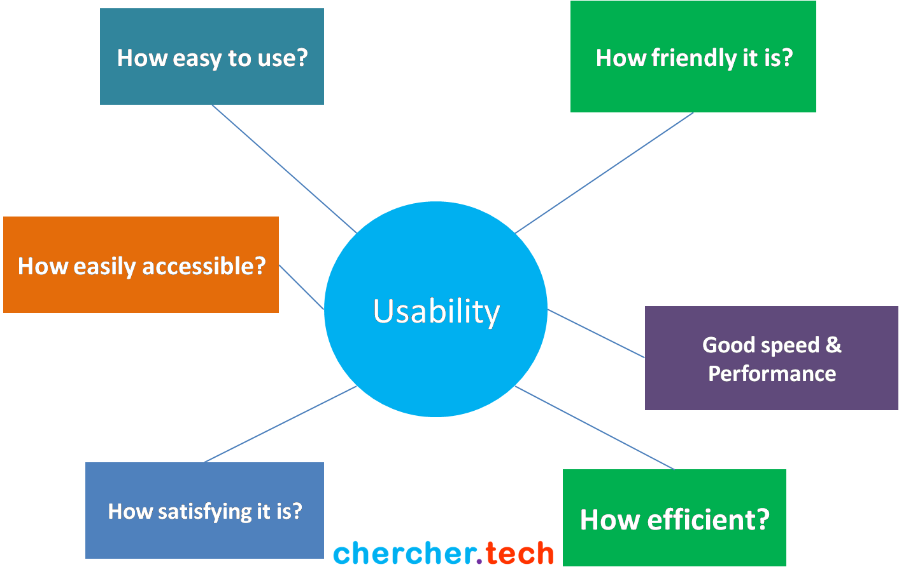

Fig 6.37: Usability Testing [20]

Some feedbacks from our usability testing are given below:

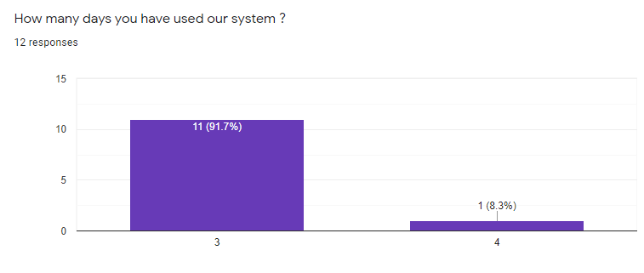

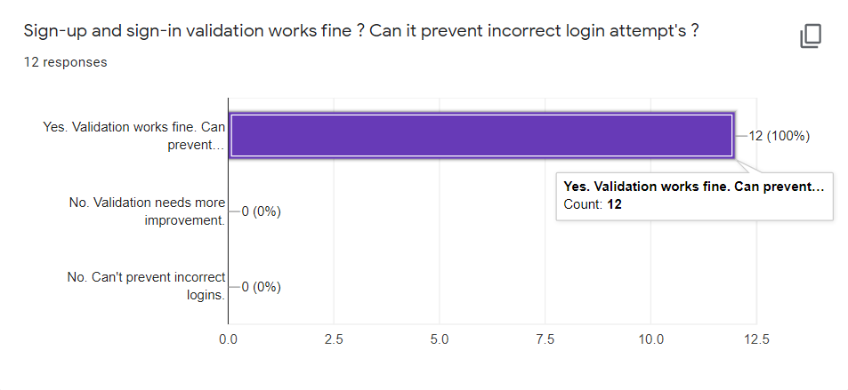(a)

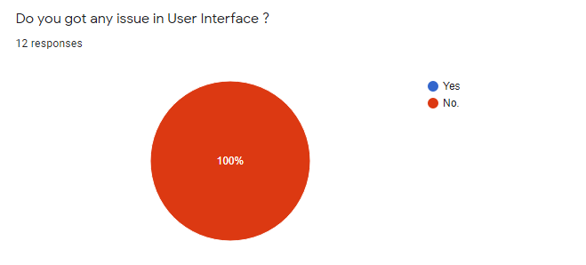(b)

(c)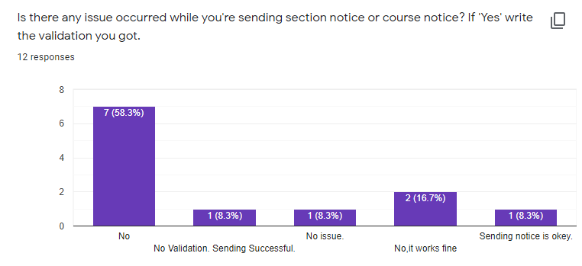

(d)

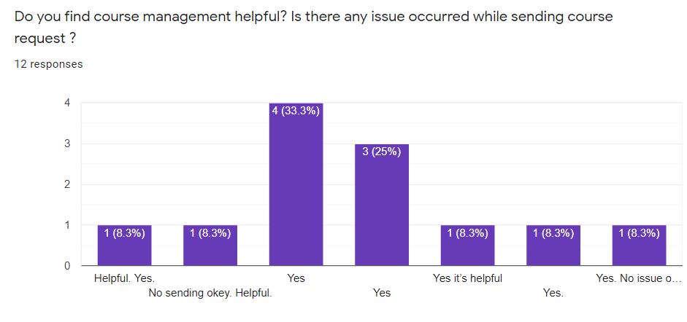

(e)

Fig 6.38: (a), (b), (c), (d) and (e) Usability testing user feedbacks

6.3.3 Advantage We Got From Testing

* Internal debates resolved by discussion from target audience demand, react and feedback.
* Potential issues and detectedproblems aresolved before final deployment.

chapter VII  
  
Conclusion & future plan

7.1 Conclusion

The project is developed with the aim to ensure the advantage of information system in academic processes of the department and to overcome the drawbacks of manual system. Our overall objective of the project **“**A Smart Course, Notice and Department Forum Management System” isto make it as an interactive information system for department which could be an easiest medium for the users to get in touch with academic information’s with maintaining proper securities for all important data. If the outcomes of the project can make the objective fulfilled it would be great achievement for the project.

7.2 Contribution of the project

The project “A Smart Course, Notice and Department Forum Management System” will be able to contribute in academic department by making the work environment of the department easier and informative. Also, it will help to build a strong communication point between the teachers and students. It will reduce waiting time in academic processes. It will make the course management easier and efficient and also will to make an interactive community within the department and ensure the advantage of it in academic processes of the department.

7.3 Future Plan

* We will try to make the application signed and deploy it to app store.
* We will try to include some new feature to the application in future to make the application up-to-date for end users.
* We will ensure the maintenance of application regularly.

**REFERENCES**

[1] Blackboard Inc., Washington, D.C., U.S. *Private Chat in Blackboard Collaborate with the Ultra Experience* (June 1, 2018). [Online Video]. Available: [https://www.youtube.com/watch? v=xvOuyj_vROw](https://www.youtube.com/watch?%20v=xvOuyj_vROw)

[2] Orell TechnoSystems. “Orell eDo.” *Orell eDo : World class e-learning software.*<https://www.orelledo.com/student-interface.php> (accessed Jan 18, 2021)

[3] “Moodle.”*What is Moodle? - Comprehensive Guide to Moodle LMS.*<https://ethinkeducation.com/what-is-moodle-guide> (accessed Jan 9, 2021)

[4] “Canvas LMS.” *To the power of the canvas learning management system.*<https://www.instructure.com/canvas> (accessed Feb 1, 2021)

[5] “AlphaLearn LMS”. *AlphaLearn Learning Management System (LMS).* <https://play.google.com/store/apps/details?id=com.horizzon.alphalearn&hl=en&gl=US> (accessed Feb 8, 2021)

[6] “Classe365”. *Classe365 Pricing, Features, Review and Alternatives.*<https://www.getapp.com/education-childcare-software/a/classe365/>(accessed Feb 8, 2021)

[7] “Requirements Engineering”. *Requirements Engineering - Requirements Validation Part – 4* . <https://medium.com/omarelgabrys-blog/requirements-engineering-requirements-validation-part-6-29778d7bde24>(accessed 09 Feb, 2021)

[8] Scott Ambler, “Agile Modeling” in *Agile Modeling : Effective Practices for eXtreme Programming and the Unified Process*, New York, 2002, pp. 08-16

[9] NataliaPeterheria. “Agile Modeling”. Why Agile SDLC Model Is The Best for Startup. <https://producttribe.com/project-management/agile-sdlc-guide> (accessed Jan 25, 2021)

[10] “Agile Software Model”. Agile Model for Software Development Lifecycle. <https://nextbigtechnology.com/agile-model-for-software-development-lifecycle> (accessed Jan 25, 2021)

[11] “Disadvantage of agile methodology.” *3 Disadvantages of agile methodology*.<https://www.lucidchart.com/blog/3-disadvantages-of-agile-methodology> (accessed Feb 3, 2021)

[12] “Agile Modeling.”*InformIT: The Trusted Technology Source for IT Pros and Developers*. <http://www.informit.com/articles/article.aspx?p=30428> (accessed Jan 25, 2021)

[13] “System Analysis”.*System Analysis and Design – Overview.*<https://www.tutorialspoint.com/system_analysis_and_design/system_analysis_and_design_overview.htm>(accessed Feb 4, 2021)

[14] “Software Process”. *A General Model of Software Design Process.* <https://www.slideshare.net/JenniferPolack/software-process-56762366>(accessed Jan 28, 2021)

[15] Scott W. Ambler. “Agile Modeling .”*An Introduction to Agile Modeling.*<http://www.agilemodeling.com/essays/introductionToAM.htm> (accessed Jan 25, 2021)

[16] “Software Testing Objective”. *Software testing objective and purposes*. <https://www.toolsqa.com/software-testing/istqb/software-testing-objectives/> (accessed Feb 8, 2021)

[17] “White Box Testing.” *What is White Box Testing? Techniques, Example and Type*. <https://www.guru99.com/white-box-testing.html>(accessed Jan 20, 2021)

[18] Software Design Center (2006), “How to Draw Data Flow Diagrams”, 2006,

Collected from “http://www.smartdraw.com/tutorials/software-dfd/dfd2.htm”,

[19] Software Design Center (2006), *“How to draw Entity Relationship Diagrams”*, 2006, Collected from “https://www.smartdraw.com/entity-relationship-diagram/”,

[20] “Software Usability Testing”. Software testing approaches <https://chercher.tech/images/testing/?MD> (accessed Jan 25, 2021)

**The End**